10.2.1 Render - Blender Render Engine - Materials
Bforartists Render Engine 5
Introduction to Materials 5
How Materials Work 6
Using Materials 7
Assigning a Material 7
Creating a new Material 8
New Material Panel Buttons 9
Reusing Existing Materials 11
Deleting a Material 12
Multiple Materials 13
Introduction to Properties 14
Material Properties 14
Material Preview 15
Options 15
Examples 16
Diffuse Shaders 16
Common Options 16
Technical Details 17
Lambert 17
Oren-Nayar 18
Options 18
Options 20
Minnaert 20
Options 20
Fresnel 21
Options 22
Specular Shaders 22
Common Options 22
Technical Details 23
CookTorr 23
Options 24
Phong 24
Options 25
Blinn 25
Options 26
Toon 26
Options 26
WardIso 27
Options 27
Color Ramps 27
Options 28
Colorbands 29
Options 30
Color Ramps 31
Options 31
Colorbands 33
Options 33
Shading 35
Transparency 36
Common Options 36
Z Buffer 37
Raytraced Transparency 37
Options 38
Examples 39
Index of Refraction 39
Fresnel 41
Depth 42
Hints 42
Transparent shadows 42
IOR values for Common Materials 43
Gasses 43
Common Liquids 43
Common Transparent Materials 44
Common Opaque Materials 44
Gemstones 44
Metals 44
Mirror Reflections 44
Options 45
Examples 48
Fresnel 48
Subsurface Scattering 50
How it works 50
Enabling Subsurface Scattering 52
Options 52
Developing your own SSS material 54
The Traditional Approach 54
A more intuitive approach 54
Examples 54
Skin 54
See also 54
Strands 55
Strands Shading 55
Texturing along the Strand 57
Strand render Simplification 58
Options 58
Shadows 59
Options 60
Shadow Receiving Object Material 60
Shadow Casting Object Material 61
Buffered Shadow Options 62
Introduction to Material Nodes 62
Accessing The Node Editor 63
Enabling Node Materials in the Material Buttons 63
Types of Material Nodes 65
Node Types 65
Color Nodes 66
MixRGB 66
Inputs 66
Outputs 67
Controls 67
RGB Curves 67
Invert 68
Inputs 68
Outputs 68
Hue Saturation Value 68
Inputs 68
Outputs 69
Convertor Nodes 69
ColorRamp Node 69
Inputs 70
Outputs 70
Controls 70
RGB to BW Node 71
Inputs 72
Outputs 72
Math Node 72
Inputs 72
Outputs 72
Controls 72
Vector Math Node 73
Inputs 74
Outputs 74
Controls 74
Squeeze Value Node 74
Inputs 75
Outputs 75
Separate RGB Node 75
Inputs 75
Outputs 75
Combine RGB Node 76
Inputs 76
Outputs 76
Separate HSV Node 76
Inputs 77
Outputs 77
Combine HSV Node 77
Inputs 77
Outputs 77
Input Nodes 78
Material Node 78
Output 79
Input 79
Controls 79
Using the Material Node with Specularity 80
Extended Material Node 82
Input 83
Output 83
Camera Data Node 83
Lamp Data Node 84
Value Node 84
RGB Node 85
Texture Node 85
Input 86
Outputs 86
Geometry Node 87
Geometry Node Example using a UV image 88
Output Node 88
Vector Nodes 89
Normal Node 89
Inputs 90
Outputs 90
Controls 90
Mapping Node 91
Inputs 91
Outputs 91
Controls 91
Vector Curves 93
Inputs 93
Outputs 93
Options 93
Materials 94
Context 94
Material slots 94
Multiple materials 94
Material naming and linking 95
Material type 95
Material Properties Overview 96
Surface and Wire materials 96
Preview 96
Diffuse 96
Specular 96
Shading 96
Transparency 97
Mirror 97
Subsurface Scattering 97
Strand 97
Options 97
Shadow 98
Volume Material 98
Halo Material 98
Special Material Effects 98
Halo Rendering 99
Options 99
Halo Panel 100
Flare Panel 102
Lens Flares 102
Halo Texturing 103
Examples 103
Dotmatrix display 103
Volume Rendering 105
Options 106
Density 106
Shading 107
Asymmetry 108
Transmission 108
Emission 109
Reflection 109
Hints 110
Lighting 110
Transparency 111
Integration 111
Options 112
Smoke and Fire 112
Create the Material 112
Add the Texture 113
Extending the Smoke Simulator: Fire! 115
Wire Render 118

Bforartists Render Engine

The Bforartists render engine is the first render engine that existed in Bforartists. It's the old render engine, present since pre 2.5 days. It still delivers some good results. But it is aged. And not longer in active development. The render engine under active development is Cycles.

Introduction to Materials

A material defines the artistic qualities of the substance that an object is made of. In its simplest form, you can use materials to show the substance an object is made of, or to “paint” the object with different colors. Usually, the substance is represented by its surface qualities (color, shininess, reflectance, etc.) but it can also exhibit more complicated effects such as transparency, diffraction and sub-surface scattering. Typical materials might be brass, skin, glass, or linen.
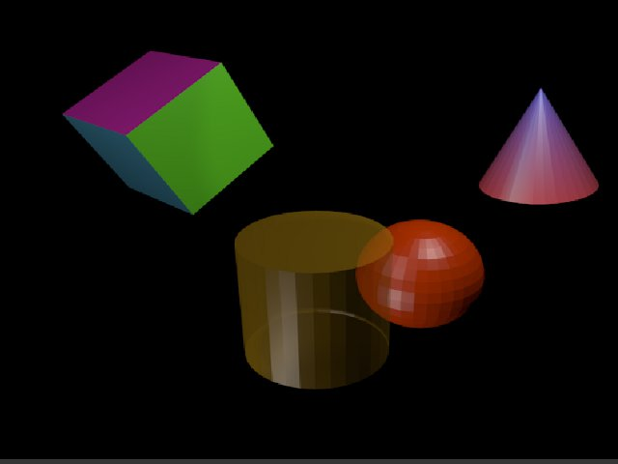
Various basic materials (single, multiple material, transparency, vertex paint).
The basic (un-textured) Bforartists material is uniform across each face of an object (although the various pixels of each face of the object may appear differently because of lighting effects). However, different faces of the object may use different materials (see Multiple Materials).
In Bforartists, materials can (optionally) have associated textures. Textures describe the substance: e.g. polished brass, dirty glass or embroidered linen. The Textures chapter describes how to add textures to materials.

How Materials Work
Before you can understand how to design effectively with materials, you must understand how simulated light and surfaces interact in Bforartists’s rendering engine and how material settings control those interactions. A deep understanding of the engine will help you to get the most from it.
The rendered image you create with Bforartists is a projection of the scene onto an imaginary surface called the viewing plane. The viewing plane is analogous to the film in a traditional camera, or the rods and cones in the human eye, except that it receives simulated light, not real light.
To render an image of a scene we must first determine what light from the scene is arriving at each point on the viewing plane. The best way to answer this question is to follow a straight line (the simulated light ray) backwards through that point on the viewing plane and the focal point (the location of the camera) until it hits a renderable surface in the scene, at which point we can determine what light would strike that point.
The surface properties and incident light angle tell us how much of that light would be reflected back along the incident viewing angle (Rendering engine basic principle).
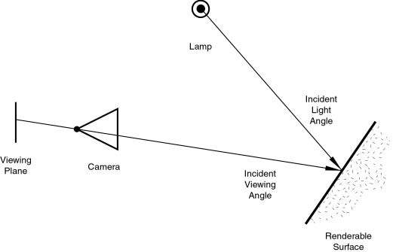
Rendering engine basic principle.
Two basic types of phenomena take place at any point on a surface when a light ray strikes it: diffusion and specular reflection. Diffusion and specular reflection are distinguished from each other mainly by the relationship between the incident light angle and the reflected light angle.
The shading (or coloring) of the object during render will then take into account the base color (as modified by the diffusion and specular reflection phenomenon) and the light intensity.
Using the internal ray tracer, other (more advanced) phenomena could occur. In ray-traced reflections, the point of a surface struck by a light ray will return the color of its surrounding environment, according to the rate of reflection of the material (mixing the base color and the surrounding environment’s) and the viewing angle.
On the other hand, in ray-traced refractions, the point of a surface struck by a light ray will return the color of its background environment, according to the rate of transparency (mixing the base color and the background environment’s along with its optional filtering value) of the material and the optional index of refraction of the material, which will distort the viewing angle.
Of course, shading of the object hit by a light ray will be about mixing all these phenomena at the same time during the rendering. The appearance of the object, when rendered, depends on many inter-related settings:
- World (Ambient color, Radiosity, Ambient Occlusion)
- Lights
- Material settings (including ambient, emission, and every other setting on every panel in that context)
- Texture(s) and how they are mixed
- Material Nodes
- Camera
- Viewing angle
- Obstructions and transparent occlusions
- Shadows from other opaque/transparent objects
- Render settings
- Object dimensions (SS settings are relevant to dimensions)
- Object shape (refractions, fresnel effects)

Using Materials
Tip
Check your Render
When designing materials (and textures and lighting), frequently check the rendered appearance of your scene, using your chosen render engine/shader settings. The appearance might be quite different from that shown in the texture display in the 3D panel.

As stated above, the material settings usually determine the surface properties of the object. There are several ways in which materials can be set up in Bforartists. Generally speaking, these are not compatible - you must choose which method you are going to use for each particular object in your scene.
First, you can set the Properties in the various Material panels.
Second, you can use Nodes; a graphical nodes editor is available.
Last, you can directly set the color of object surfaces using various special effects. Strictly speaking, these are not materials at all, but they are included here because they affect the appearance of your objects. These include Vertex Painting, Wire Rendering, Volume Rendering, and Halo Rendering.
The exact effect of Material settings can be affected by a number of system settings. First and foremost is the Render Engine used - Cycles and the Bforartists Render Engine (aka Bforartists Internal or BI) require quite different illumination levels to achieve similar results, and even then the appearance of objects can be quite different. Also, the material properties settings can be affected by the texture method used (Single Texture, Multitexture or GLSL). So it is recommended to always select the appropriate system settings before starting the design of materials.

Assigning a Material

Materials available in the currently-open Bforartists file can be investigated by clicking on the Materials button
in the Properties Window Header. In this section we look at how to assign or remove a material to/from the Active Object in Bforartists, either by:
- creating a new material,
- re-using an existing material, or
- deleting a material.
We also give hints about practical material usage.

Creating a new Material
Every time a new Object is created it has no material linked to it. You can create a new material for the object by
- Selecting the object
- In the Properties window, click on the object button
- Click on the Materials button in the Properties Panel Header (1)
The Shading context window then appears. This contains the following elements:
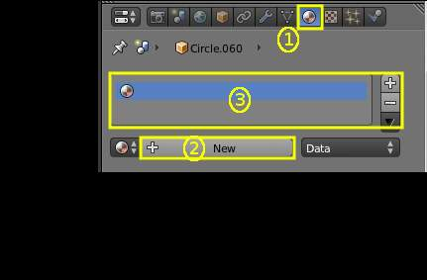
Add new material
- Context - The currently-selected scene and object
- Object Material Slots (3) - this window shows the “slots” for the material (or materials) that this object data contains.
- Active Material (2). Initially empty, asking for “New”.
To add a new material, click “+” in the Active Material box. This action has a series of effects:
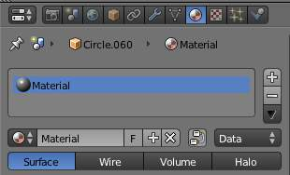
Materials Panel with New Entry
- opens the new material in the Active Material box,
- brings up additional buttons in the immediate panel,
- adds the new material to the Available Materials list,
- adds the new material to the Object Material Slots list for the active object (or its object data - see below)
- brings up a preview of the new material,
- provides you with a range of panels allowing you to select the properties of the new material.

New Material Panel Buttons
Details of the additional buttons which appear in the Material panel for a new Active Material are as follows:
Active Material
Available Materials See Reusing Existing Materials below.
Name
Like other data-blocks, Bforartists will automatically set the name of the new material to Material, Material.001 and so on. You can change this by over-typing with your own choice of name.
Number of Users
Specifies the number of meshes which use this material.
F - Fake User
When enabled, this material will always be saved within the Bforartists file, even if it has no meshes which use it (see Deleting a Material).
X
Delete this material (see Deleting a Material).
Tip
Naming materials
It’s a very good idea to give your materials clear names so you can keep track of them, especially when they’re linked to multiple objects. Try to make your names descriptive of the material, not its function (e.g. “Yellow Painted” rather than “Kitchen Table Color”)

Nodes
If dark, use the Shader Nodes to generate the material.
Data
Specifies whether the material is to be linked to the Object or to the Object Data.
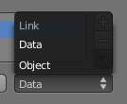
Link material to object or to object’s data
The Link pop-up menu has two choices, Data and Object. These two menu choices determine whether the material is linked to the object or to the data, (in this case) the mesh (or curve, nurbs, etc.). The Data menu item determines that this material will be linked to the mesh’s data-block which is linked to the object’s data-block. The Object menu item determines that the material will be linked to the object’s data block directly. This has consequences of course. For example, different objects may share the same mesh data-block. Since this data-block defines the shape of the object, any change in edit mode will be reflected on all of those objects. Moreover, anything linked to that mesh data-block will be shared by every object that shares that mesh. So, if the material is linked to the mesh, every object will share it. On the other hand, if the material is linked directly to the object data-block, the objects can have different materials and still share the same mesh. Short explanation: If connected to the object, you can have several instances of the same obData using different materials. If linked to mesh data, you can’t. See Data System for more information.
Object Render Format (menu)
This menu has four options which define how the object is to be rendered:
Surface
Material applied to object planes.
Wire
Material applied to wires following the object edges
Volume
Material applied to the object volume.
Halos
Material applied to halos around each object vertex.
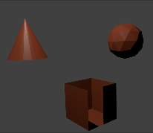
Surface
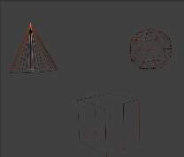
Wire
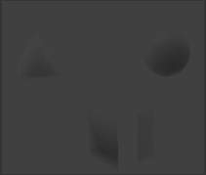
Volume
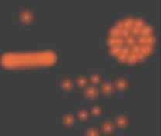
Halo

Reusing Existing Materials
Bforartists is built to allow you to reuse anything, including material settings, between many objects. Instead of creating duplicate materials, you can simply re-use an existing material. There are several ways to do this using the Available Materials menu:
Single Object - With the object selected, click the sphere located to the left of the Material name. A drop-down list appears showing all the materials available in the current Bforartists file. To use one, just click on it.
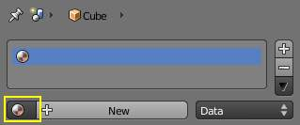
Select an existing material.
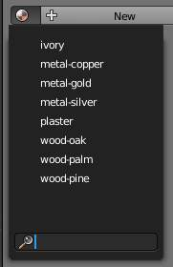
List of available materials

Tip
Searching for Materials
The search field at the bottom of the material list allows you to search the names in the list. For example, by entering “wood” all existent materials are filtered so that only materials containing “wood” are displayed in the list.
Multiple Objects - In the 3D View, with Ctrl-L you can quickly link all selected objects to the material (and other aspects) of the active object. Very useful if you need to set a large number of objects to the same material; just select all of them, then the object that has the desired material, and Ctrl-L link them to that “parent”. (See Tip on Linking Data in Creating about data linking.)

Deleting a Material
To delete a material, select the material and click X in the Available Materials List entry.
Although the material will seem to disappear immediately, the Delete action can depend on how the material is used elsewhere.
If the material is linked to the Object and there are other objects which use this material, then the material will be removed from that object (but remain on all its other objects).
If the “Fake User” button (F) has been lit in the Available Materials list, then the material will be retained when the file is saved, even if it has no users.
Only if it has 0 “real” users, and no “Fake” user, will the material be permanently deleted. Note that it will still remain in the Materials list until the Bforartists file is saved, but will have disappeared when the file is reloaded.

Multiple Materials

Normally, different colors or patterns on an object are achieved by adding textures to your materials. However, in some applications you can obtain multiple colors on an object by assigning different materials to the individual faces of the object.
Add new material
To apply several materials to different faces of the same object, you use the Material Slots options (3) in the Materials header panel.
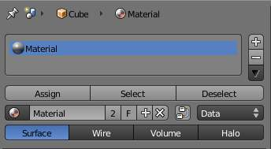
Material menu in edit mode
The workflow for applying a second material to some faces of an object covered by a base material is as follows:
- In Object mode, apply the base material to the whole object (as shown in Assigning a material)
- Create/select the second material (the whole object will change to this new material).
- In the Active Material box (2), re-select the base material.
- Go to Edit Mode - Face Select (a new box appears above the Active Material box with Assign/Select/Deselect).
- Select the face/faces to be colored with the second material.
- In the Object Material Slots box (3), click the Plus to create a new slot, and while this is still active, click on the second material in the Available Materials list.
- Click the Assign button, and the second material will appear on the selected object faces.
- You can also make this new material a copy of an existing material by adding the data block:
Select object, get the material, (R Click) - Copy data to clipboard. When you have renamed the material, click “Data - Data” to link to the existing material. Proceed to assign faces as required. NB: If you change the material on the original object, the new object color changes too.

Introduction to Properties

Material Properties
Materials can have a wide array of properties. It is the combination of all of these things that define the way a material looks, and how objects using that material will appear when rendered. These properties are set using the various Properties panels.
Remember that the appearance of your materials are affected by the way that they are rendered (surface, wire, volume or halo), and by the rendering engine (Bforartists, Cycles, or Game) used. Most properties for images rendered using Cycles can only be controlled using the Node system.
The list below sets out the various Properties panels available in Bforartists Render and Game Engine, and brief details of their scope. Details of their controls and settings are given on the relevant pages.
Preview
A preview of the current material mapped on to one of several basic objects.
Diffuse Shaders
The basic color of the material, together with different models for dispersion.
Specular Shaders
The reflected highlights: color, strength and different models for dispersion.
Color Ramps
How to vary the base color over a surface in both Diffuse ans Specular shaders.
Shading
Properties of various characteristics of the shading model for the material.
Transparency
Can other objects be seen through the object, and if so, how?
Mirror
(Only Bforartists Render): Reflective properties of the material.
SubSurface Scattering
(Only Bforartists Render): Simulates semi-translucent objects in which light enters, bounces around, then exits in a different place.
Strand
(Only Bforartists Render): For use when surfaces are covered with hair, fur, etc.
Options
Various options for shading and coloring the object.
Shadow:
Controls how objects using this material cast and receive shadows.
Game Settings
(Only Bforartists Render): Controls settings for real-time rendering of Game Engine objects.

Material Preview

Reference
Mode: All Modes
Panel: Shading/Material Context –> Preview

The Preview panel gives a quick visualization of the active material and its properties, including its Shaders, Ramps, Mirror Transp properties and Textures. It provides several shapes that are very useful for designing new shaders: for some shaders (like those based on Ramp colors, or a Diffuse shader like Minnaert), one needs fairly complex or specific previewing shapes to decide if the shader being designed achieves its goal.

Options
Flat XY plane
Useful for previewing textures and materials of flat objects, like walls, paper and such.
Sphere
Useful for previewing textures and materials of sphere-like objects, but also to design metals and other reflective/transparent materials, thanks to the checkered background.
Cube
Useful for previewing textures and materials of cube-like objects, but also to design procedural textures. Features a checkered background.
Monkey
Useful for previewing textures and materials of organic or complex non-primitive shapes. Features a checkered background.
Hair strands
Useful for previewing textures and materials of strand-like objects, like grass, fur, feathers and hair. Features a checkered background.
Large Sphere with Sky
Useful for previewing textures and materials of sphere-like objects, but also to design metals and other reflective materials, thanks to the gradient Sky background.
Preview uses OSA (oversampling). Whatever the preview option, it will make use of OSA (oversampling) in order to provide better quality. Disable this option if your computer is already slow or old.

Examples
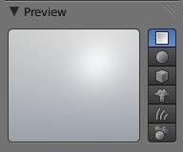  Plane preview. | 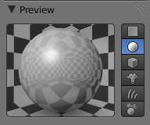  Sphere preview. | 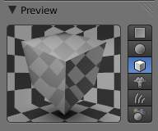  Cube preview.
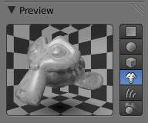  Monkey preview. | 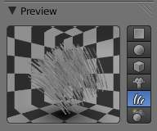  Hair Strands preview. | 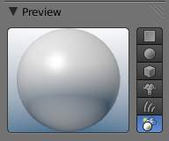  Sky Sphere preview.

Diffuse Shaders

Reference
Mode: All Modes
Panel: Shading/Material Context –> Diffuse

A diffuse shader determines, simply speaking, the general color of a material when light shines on it. Most shaders that are designed to mimic reality give a smooth falloff from bright to dark from the point of the strongest illumination to the shadowed areas, but Bforartists also has other shaders for various special effects.

Common Options
All diffuse shaders have the following options:
Color
Select the base diffuse color of the material.
Intensity
The shader’s brightness, or more accurately, the amount of incident light energy that is actually diffusely reflected towards the camera.
Ramp
Allows you to set a range of colors for the Material, and define how the range will vary over a surface. See Color Ramps for details.

Technical Details
Light striking a surface and then re-irradiated via a Diffusion phenomenon will be scattered, i.e., re-irradiated in all directions isotropically. This means that the camera will see the same amount of light from that surface point no matter what the incident viewing angle is. It is this quality that makes diffuse light viewpoint independent. Of course, the amount of light that strikes the surface depends on the incident light angle. If most of the light striking a surface is reflected diffusely, the surface will have a matte appearance (Light re-irradiated in the diffusion phenomenon.).
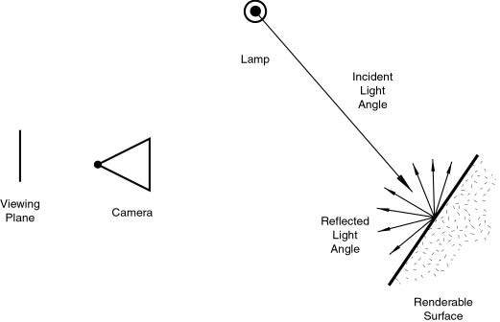
Light re-irradiated in the diffusion phenomenon.
Tip
Shader Names
Some shaders’ names may sound odd - they are traditionally named after the people who first introduced the models on which they are based.

Lambert
Reference
Mode: All Modes
Panel: Shading/Material Context –> Shaders

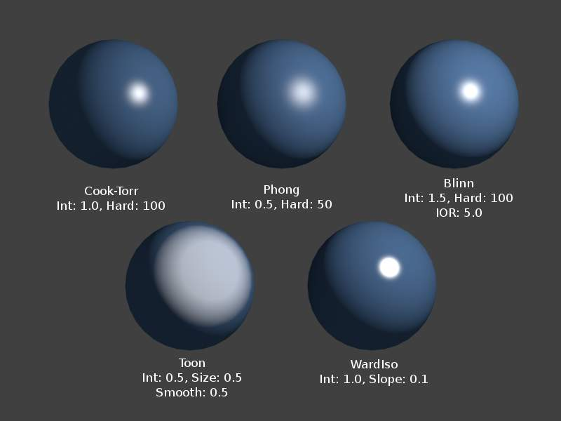
Lambert Shader
This is Bforartists’s default diffuse shader, and is a good general all-around workhorse for materials showing low levels of specular reflection.
Johann Heinrich Lambert (1728-1777)
was a Swiss mathematician, physicist and astronomer who published works on the reflection of light, most notably the Beer-Lambert Law which formulates the law of light absorption.
This shader has only the default option, determining how much of available light is reflected. Default is 0.8, to allow other objects to be brighter.
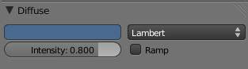
The Lambert diffuse shader settings.

Oren-Nayar
Reference
Mode: All Modes
Panel: Shading/Material Context –> Shaders

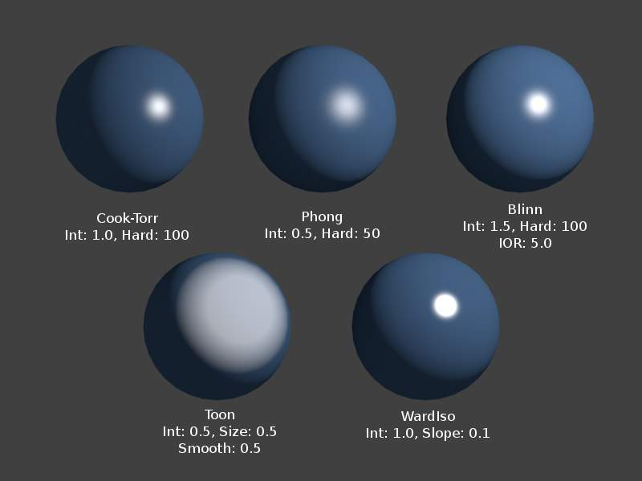
Oren-Nayar Shader
Oren-Nayar takes a somewhat more ‘physical’ approach to the diffusion phenomena as it takes into account the amount of microscopic roughness of the surface. Michael Oren and Shree K. Nayar Their reflectance model, developed in the early 1990s, is a generalization of Lambert’s law now widely used in computer graphics.

Options
Roughness
The roughness of the surface, and hence, the amount of diffuse scattering.
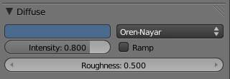
The Oren-Nayar diffuse shader settings.
Toon

Reference
Mode: All Modes
Panel: Shading/Material Context –> Shaders

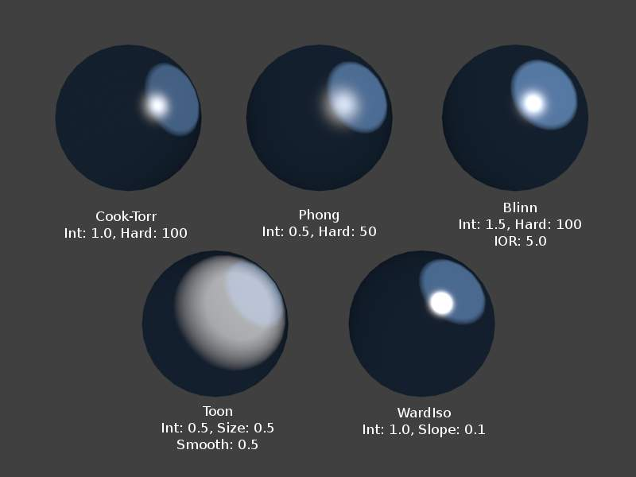
Toon Shader, Different Spec
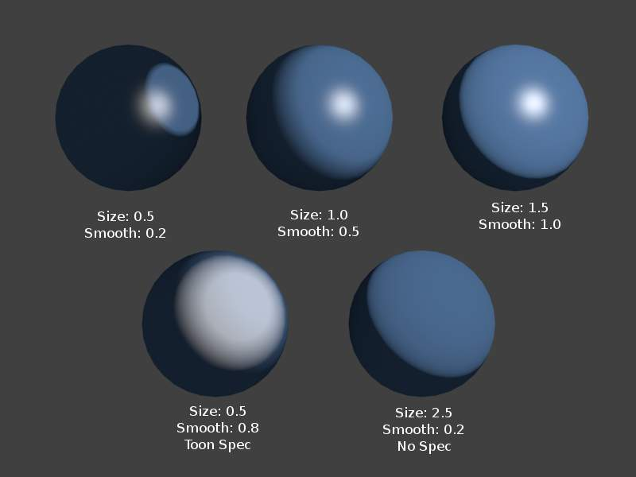
Toon Shader Variations
The Toon shader is a very ‘un-physical’ shader in that it is not meant to fake reality but to produce cartoon cel styled rendering, with clear boundaries between light and shadow and uniformly lit/shadowed regions.

Options
Size
The size of the lit area
Smooth
The softness of the boundary between lit and shadowed areas
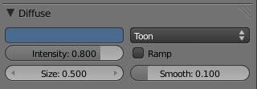
The Toon diffuse shader settings.

Minnaert
Reference
Mode: All Modes
Panel: Shading/Material Context –> Shaders

Minnaert Shader
Minnaert works by darkening parts of the standard Lambertian shader, so if Dark is 1 you get exactly the Lambertian result. Higher darkness values will darken the center of an object (where it points towards the viewer). Lower darkness values will lighten the edges of the object, making it look somewhat velvet. Marcel Minnaert (1893-1970) was a Belgian astronomer interested in the effects of the atmosphere on light and images who in 1954 published a book entitled The Nature of Light and Color in the Open Air.

Options
Dark
The darkness of the ‘lit’ areas (higher) or the darkness of the edges pointing away from the light source (lower).
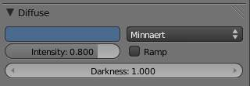
The Minnaert diffuse shader settings.

Fresnel
Reference
Mode: All Modes
Panel: Shading/Material Context –> Shaders

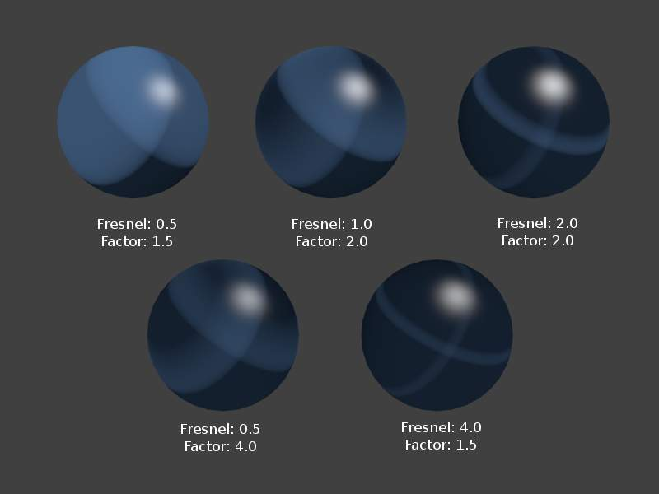
Various settings for the Fresnel shader, Cook-Torr Specular shader kept at Intensity 0.5, Hardness: 50
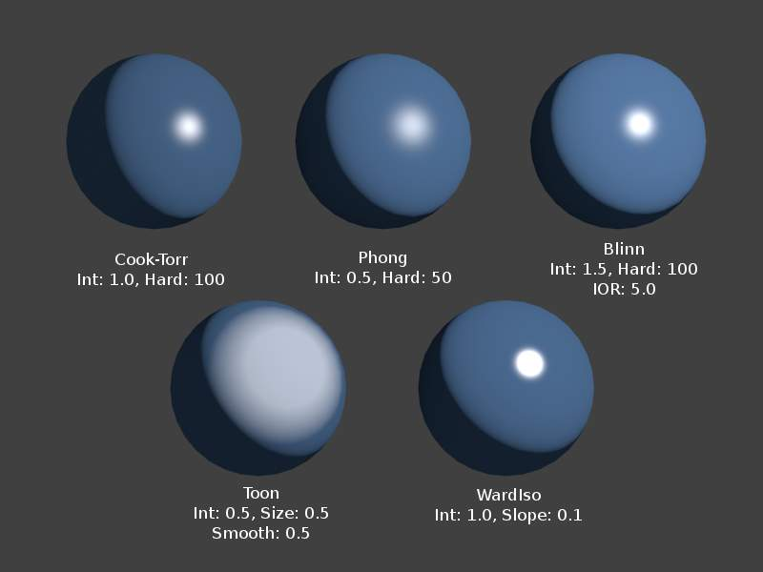
Fresnel Shader, Different Spec
With a Fresnel shader the amount of diffuse reflected light depends on the incidence angle, i. e. from the direction of the light source. Areas pointing directly towards the light source appear darker; areas perpendicular to the incoming light become brighter. Augustin-Jean Fresnel (1788-1827) was a French physicist who contributed significantly to the establishment of the theory of wave optics.

Options
Fresnel
Power of the Fresnel effect, 5.0 is max.
Factor
Blending factor of the Fresnel factor to blend in, 5.0 is max.
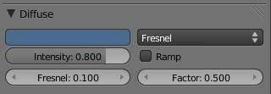
The Fresnel diffuse shader settings.

Specular Shaders

Reference
Mode: All Modes
Panel: Shading/Material Context –> Specular

Specular shaders create the bright highlights that one would see on a glossy surface, mimicking the reflection of light sources. Unlike diffuse shading, specular reflection is viewpoint dependent. According to Snell’s Law, light striking a specular surface will be reflected at an angle which mirrors the incident light angle (with regard to the surface’s normal), which makes the viewing angle very important.
Tip
Not a Mirror!
It is important to stress that the specular reflection phenomenon discussed here is not the reflection we would see in a mirror, but rather the light highlights we would see on a glossy surface. To obtain true mirror-like reflections you would need to use the internal raytracer. Please refer to section RENDERING of this manual.

Common Options
Each specular shader share the following common options:
Specular Color
The color of the specular highlight
Intensity
The intensity, or brightness of the specular highlight. This has a range of [0-1].
Ramp
Allows you to set a range of specular colors for Material, and define how the range will vary over a surface. See Ramps for details.
As a result, a material has at least two different colors, a diffuse, and a specular one. The specular color is normally set to pure white (the same “pure white” as the reflected light source), but it can be set to different values for various effects (e.g. metals tend to have colored highlights).

Technical Details
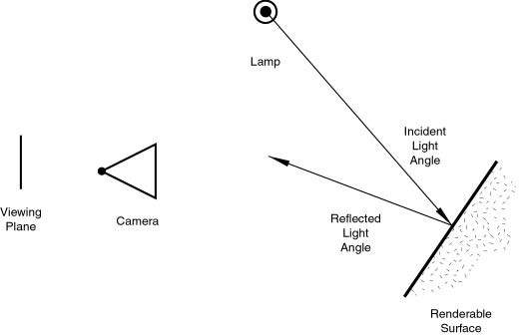
Specular Reflection.
In reality, the quality of Diffuse and Specular reflection are generated during the same process of light scattering, but are not the same. Diffusion is actually subsurface scattering at a very small scale.
Imagine that a surface is made up of extremely microscopic semi-transparent, reflective facets. The sharpness of Specular reflection is determined by the distribution of the angle of these microfacets on the surface of an object. The more deep and jagged these facets are, the more the light spreads when it hits the surface. When these facets are flatter against the “macrosurface”, the surface will have a tighter reflection, closer to a mirror. This is a condensed explanation of the generally accepted microfacet theory of reflectance, which is the basis of all modern BRDFs (Bi-directional Reflectance Distribution Functions), or shading models.
Because these microfacets are transparent, some light that hits them travels into the surface and diffuses. The light that makes it back out is roughly Lambertian most of the time, meaning that it spreads evenly in all directions. It is also attenuated by the pigmentation in the surface, hence creating what we perceive as diffuse, and the color of an object.
Note that at glancing angles, the reflectivity of a surface will always go to 1.
If it is difficult for you to understand this relationship, try to imagine a ball (say, of centimeter scale): if you throw it against a wall of raw stones (with a scale of roughness of a decimeter), it will bounce in a different direction each time, and you will likely quickly lose it! On the other hand, if you throw it against a smooth concrete wall (with a roughness of, say, a millimeter scale), you can quite easily anticipate its bounce, which follow (more or less!) the same law as the light reflection.

CookTorr
Reference
Mode: All Modes
Panel: Shading/Material Context –> Shaders

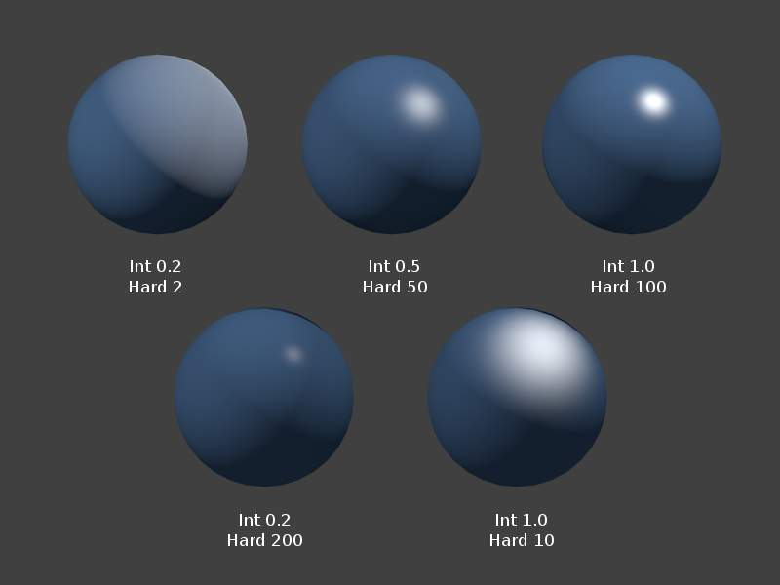
CookTorr Shader (Lambert 0.8)
CookTorr (Cook-Torrance) is a basic specular shader that is most useful for creating shiny plastic surfaces. It is a slightly optimized version of Phong. Robert L. Cook (LucasFilm) and Kenneth E. Torrance (Cornell University) In their 1982 paper A Reflectance Model for Computer Graphics (PDF), they described “a new reflectance model for rendering computer synthesized images” and applied it to the simulation of metal and plastic.

Options
Hardness
Size of the specular highlight

Phong
Reference
Mode: All Modes
Panel: Shading/Material Context –> Shaders

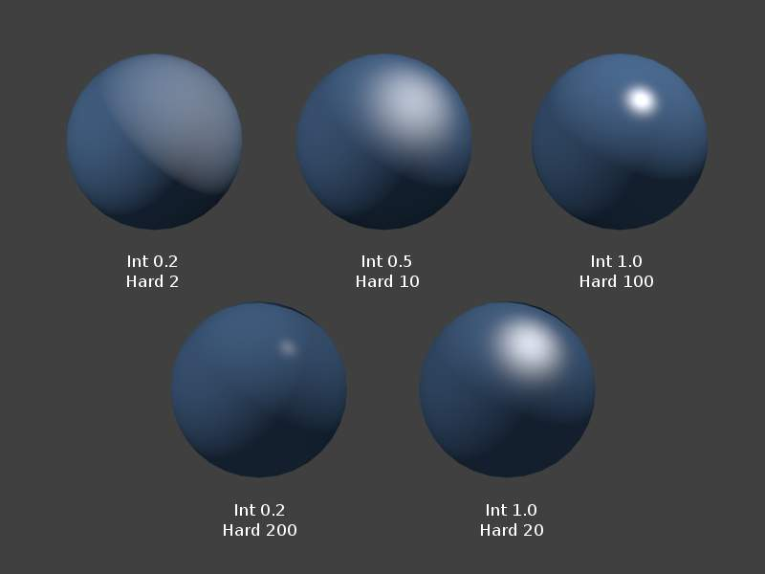
Phong Shader (Lambert 0.8)
Phong is a basic shader that’s very similar to CookTorr, but is better for skin and organic surfaces. Bui Tuong Phong (1942-1975) was a Vietnamese-born computer graphics pioneer that developed the first algorithm for simulating specular phenomenon. His model included components not only for specular lighting, but also diffuse and ambient lighting.

Options
Hardness
Size of the specular highlight.
Tip
Planet Atmosphere
Because of its fuzziness, this shader is good for atmosphere around a planet. Add a sphere around the planet, slightly larger than the planet. For its material, use a phong specular shader. Set it to a very low alpha (.05), zero diffuse, low hardness (5) but high specularity (1).

Blinn
Reference
Mode: All Modes
Panel: Shading/Material Context –> Shaders

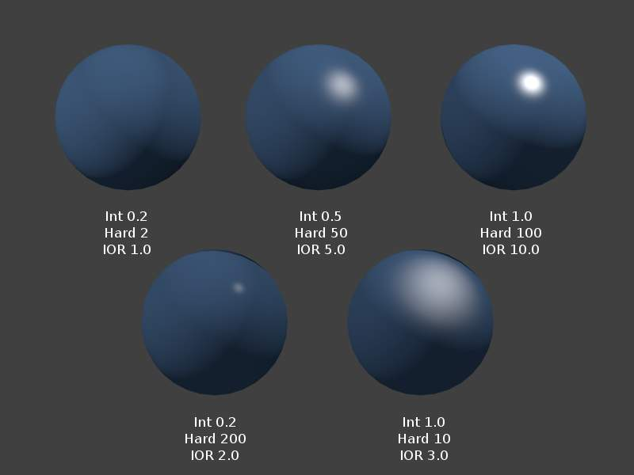
Blinn Shader (Oren-Nayar Int 0.8, Rough 0.5)
Blinn is a more ‘physical’ specular shader, often used with the Oren-Nayar diffuse shader. It can be more controllable because it adds a fourth option, an index of refraction, to the aforementioned three. James F. Blinn worked at NASA’s Jet Propulsion Laboratory and became widely known for his work on Carl Sagan’s TV documentary Cosmos. The model he described in his 1977 paper Models of Light Reflection for Computer Synthesized Pictures (PDF) included changes in specular intensity with light direction and more accurately positioned highlights on a surface.

Options
Hardness
Size of the specular highlight. The Blinn shader is capable of much tighter specular highlights than Phong or CookTorr.
IOR
‘Index of Refraction’. This parameter is not actually used to compute refraction of light rays through the material (a ray tracer is needed for that), but to correctly compute specular reflection intensity and extension via Snell’s Law.

Toon
Reference
Mode: All Modes
Panel: Shading/Material Context –> Shaders

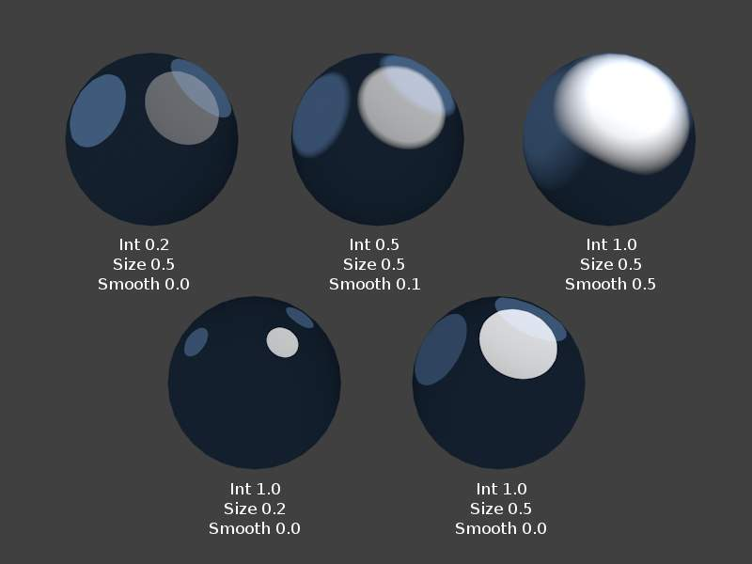
Toon Specular Shader (Toon Diffuse, Int 0.8, Size & Smooth match)
The Toon specular shader matches the Toon diffuse shader. It is designed to produce the sharp, uniform highlights of cartoon cels.

Options
Size
Size of the specular highlight.
Smooth
Softness of the highlight’s edge.
Tip
Alternative Method
The Toon shader effect can also be accomplished in a more controllable way using ColorRamps.

WardIso
Reference
Mode: All Modes
Panel: Shading/Material Context –> Shaders

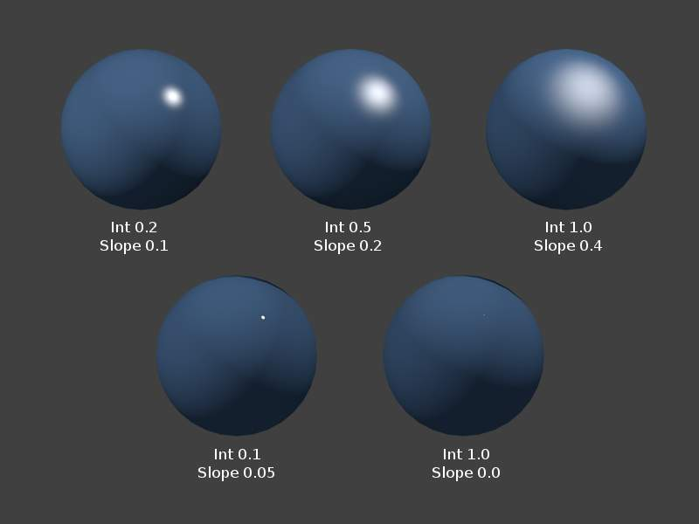
WardIso Shader
WardIso is a flexible specular shader that can be useful for metal or plastic.
Gregory J. Ward
developed a relatively simple model that obeyed the most basic laws of physics. In his 1992 paper, Measuring and modeling anisotropic reaection, Ward introduced a Bidirectional Re?ectance Distribution Function (BRDF) since then widely used in computer graphics because the few parameters it uses are simple to control. His model could represent both isotropic surfaces (independent of light direction) and anisotropic surfaces (direction dependent). In Bforartists, the Ward specular shader is still called Ward Isotropic but is actually anisotropic. (PDF)

Options
Slope
Standard deviation for of surface slope. Previously known as the root-mean-square or rms value, this parameter in effect controls the size of the specular highlight, though using a different method to that of the other specular shaders. It is capable of extremely sharp highlights.

Color Ramps

Reference
Mode: All Modes
Panel: Context Shading –> sub-context Material –> Ramps

In many real life situations - like skin or metals - the color of diffuse and specular reflections can differ slightly, based on the amount of energy a surface receives or on the light angle of incidence. The Ramp Shader options in Bforartists allow you to set a range of colors for a Material, and define how the range will vary over a surface, and how it blends with the ‘actual color’ (typically from a material or as output of a texture).
Ramps allow you to precisely control the color gradient across a material, rather than just a simple blend from a brightened color to a darkened color, from the most strongly lit area to the darkest lit area. As well as several options for controlling the gradient from lit to shadowed, ramps also provide ‘normal’ input, to define a gradient from surfaces facing the camera to surfaces facing away from the camera. This is often used for materials like some types of metallic car paint that change color based on viewing angle.
Since texture calculations in Bforartists happen before shading, the Ramp Shader can completely replace texture or material color. But by use of the mixing options and Alpha values it is possible to create an additional layer of shading in Bforartists materials.

Options
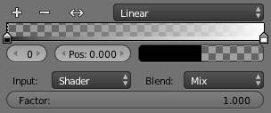
Ramps Panel
The separate Ramp panels for the Diffuse shader and the Specular shader respectively can be toggled on and off using the
button.
By default the Ramp panel opens with two colors; the first stop (0) is black and transparent (Alpha=0) and the second stop (1) is white and opaque (Alpha=1).
The position of the color stop markers can be altered by either (1) dragging the stop marker in the colorband or (2) by changing the Pos value in the
box.
Color and alpha values for each marker can be set by clicking the
box.
Input
The input menu contains the following options for defining the gradient:
Shader
The value as delivered by the material’s shader (Lambert, CookTorr) defines the color. Here the amount of light doesn’t matter for color, only the direction of the light.
Energy
As Shader, now also lamp energy, color, and distance are taken into account. This makes the material change color when more light shines on it.
Normal
The surface normal, relative to the camera, is used for the Ramp Shader. This is possible with a texture as well, but added for convenience.
Result
While all three previous options work per lamp, this option only works after shading calculations. This allows full control over the entire shading, including ‘Toon’ style results. Using alpha values here is most useful for tweaking a finishing touch to a material.
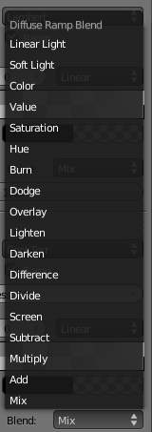
Blend pop-up menu
Blend
A list of the various blending modes available for blending the ramp shader with the color from Input.
Factor
This slider denotes the overall factor of the ramp shader with the color from Input.

Colorbands
Reference
Mode: All Modes
Panel: Context Shading –> sub-context Material –> Ramps

A colorband can contain a gradient through a sequence of many colors (with alpha), each color acting across a certain position in the spectrum. Colorbands are used in both materials and textures, as well in other places where a range of colors can be computed and displayed.

Options
Add
Add a new mark to the center of the colorband with the default color (neutral gray). New marks can also be added by Ctrl-LMB clicking in the colorband itself, which will add the mark at the position of the click with the same color that already exists underneath the mouse pointer.
Delete
Remove the currently selected mark from the colorband.
F
Flip the colorband.
0
The number of the active mark. The values for this mark are those being displayed, and in the colorband, the active mark is displayed as a dashed line. Another marker can be selected (1) using the arrows in the
slider, (2) by clicking on the number being displayed and entering a number of a color mark, or (3) by LMB clicking a marker in the colorband.
Pos
The position of the active color mark in the colorband (range 0.0–1.0). The position of the color marks can also be changed by LMB dragging them in the colorband.
Note
Reordering colors
If the position of the color marks are reordered, they will be automatically renumbered so that they always start with 0 from the left and increment to the right.

The Colorswatch right of the Position slider displays the color of the active mark. LMB click it to display a color picker in which values for color (RGB) and transparency (Alpha) can be set.
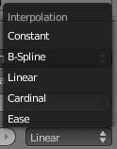
Interpolation pop-up menu
Interpolation
Various modes of interpolation between marker’s values can be chosen in the Interpolation menu:
Ease
Ease by quadratic equation.
Cardinal
Cardinal.
Linear
Linear (default). A smooth, consistent transition between colors.
B-Spline
B-Spline.
Constant
Constant.

Color Ramps

Reference
Mode: All Modes
Panel: Context Shading –> sub-context Material –> Ramps

In many real life situations - like skin or metals - the color of diffuse and specular reflections can differ slightly, based on the amount of energy a surface receives or on the light angle of incidence. The Ramp Shader options in Bforartists allow you to set a range of colors for a Material, and define how the range will vary over a surface, and how it blends with the ‘actual color’ (typically from a material or as output of a texture).
Ramps allow you to precisely control the color gradient across a material, rather than just a simple blend from a brightened color to a darkened color, from the most strongly lit area to the darkest lit area. As well as several options for controlling the gradient from lit to shadowed, ramps also provide ‘normal’ input, to define a gradient from surfaces facing the camera to surfaces facing away from the camera. This is often used for materials like some types of metallic car paint that change color based on viewing angle.
Since texture calculations in Bforartists happen before shading, the Ramp Shader can completely replace texture or material color. But by use of the mixing options and Alpha values it is possible to create an additional layer of shading in Bforartists materials.

Options
Ramps Panel
The separate Ramp panels for the Diffuse shader and the Specular shader respectively can be toggled on and off using the
button.
By default the Ramp panel opens with two colors; the first stop (0) is black and transparent (Alpha=0) and the second stop (1) is white and opaque (Alpha=1).
The position of the color stop markers can be altered by either (1) dragging the stop marker in the colorband or (2) by changing the Pos value in the
box.
Color and alpha values for each marker can be set by clicking the
box.
Input
The input menu contains the following options for defining the gradient:
Shader
The value as delivered by the material’s shader (Lambert, CookTorr) defines the color. Here the amount of light doesn’t matter for color, only the direction of the light.
Energy
As Shader, now also lamp energy, color, and distance are taken into account. This makes the material change color when more light shines on it.
Normal
The surface normal, relative to the camera, is used for the Ramp Shader. This is possible with a texture as well, but added for convenience.
Result
While all three previous options work per lamp, this option only works after shading calculations. This allows full control over the entire shading, including ‘Toon’ style results. Using alpha values here is most useful for tweaking a finishing touch to a material.
Blend pop-up menu
Blend
A list of the various blending modes available for blending the ramp shader with the color from Input.
Factor
This slider denotes the overall factor of the ramp shader with the color from Input.

Colorbands
Reference
Mode: All Modes
Panel: Context Shading –> sub-context Material –> Ramps

A colorband can contain a gradient through a sequence of many colors (with alpha), each color acting across a certain position in the spectrum. Colorbands are used in both materials and textures, as well in other places where a range of colors can be computed and displayed.

Options
Add
Add a new mark to the center of the colorband with the default color (neutral gray). New marks can also be added by Ctrl-LMB clicking in the colorband itself, which will add the mark at the position of the click with the same color that already exists underneath the mouse pointer.
Delete
Remove the currently selected mark from the colorband.
F
Flip the colorband.
0
The number of the active mark. The values for this mark are those being displayed, and in the colorband, the active mark is displayed as a dashed line. Another marker can be selected (1) using the arrows in the
slider, (2) by clicking on the number being displayed and entering a number of a color mark, or (3) by LMB clicking a marker in the colorband.
Pos
The position of the active color mark in the colorband (range 0.0–1.0). The position of the color marks can also be changed by LMB dragging them in the colorband.
Note
Reordering colors
If the position of the color marks are reordered, they will be automatically renumbered so that they always start with 0 from the left and increment to the right.

The Colorswatch right of the Position slider displays the color of the active mark. LMB click it to display a color picker in which values for color (RGB) and transparency (Alpha) can be set.
Interpolation pop-up menu
Interpolation
Various modes of interpolation between marker’s values can be chosen in the Interpolation menu:
Ease
Ease by quadratic equation.
Cardinal
Cardinal.
Linear
Linear (default). A smooth, consistent transition between colors.
B-Spline
B-Spline.
Constant
Constant.

Shading

In the separate Shading tab six more options are available:
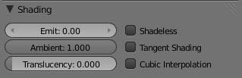
Shading menu, default settings
Emit
Amount of light to emit
Ambient
Amount of global ambient color the material receives. Each material has an Ambient slider that lets you choose how much ambient light that object receives. Set to 1.0 by default.
You should set this slider depending on the amount of ambient light you think the object will receive. Something deep in the cave will not get any ambient light, whereas something close to the entrance will get more. Note that you can animate this effect, to change it as the object comes out of the shadows and into the light.
Settings for Ambient Occlusion and Environment Lighting can be found in the World menu, with parameters affecting both these lighting components found in the World Gather menu.
Translucency
Amount of diffuse shading on the back side
Shadeless
Make this material insensitive to light or shadow; gives a solid, uniform color to the whole object.
Tangent Shading
Use the material’s tangent vector instead of the normal for shading - for anisotropic shading effects (e.g. soft hair and brushed metal). This shading was introduced in 2.42, see also settings for strand rendering in the menu further down and in the Particle System menu.
Cubic Interpolation
Use cubic interpolation for diffuse values. Enhances the contrast between light areas and shadowed areas
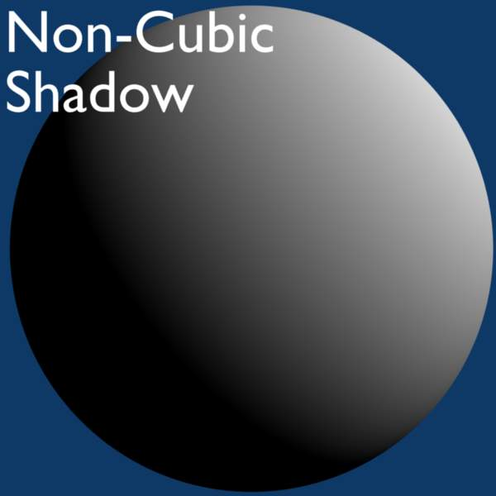  Without Cubic enabled. | 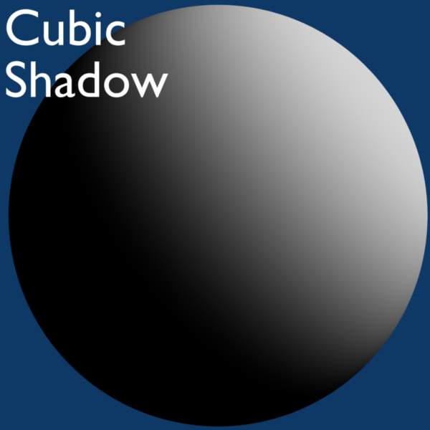  With Cubic enabled.

Transparency

Reference
Mode: All Modes
Panel: Shading/Material Context –> Transparency

Materials in Bforartists can be set to be transparent, so that light can pass through any objects using the material. Transparency is controlled using an “alpha” channel, where each pixel has an additional value, range 0-1, in addition to its RGB color values. If alpha=0, then the pixel is transparent, and the RGB values for the surface contribute nothing to the pixel’s appearance; for alpha=1, the surface is fully opaque, and the color of the surface determines the final color of the pixel.
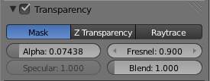
Transparency Panel
In Bforartists, there are three ways in which the transparency of a material can be set: Mask, Z-Buffer and Ray-trace. Each of these is explained in more detail below. The Material Preview option with a sphere object gives a good demonstration of the capabilities of these three options.

Common Options
The following property controls are available for all transparency options:
Alpha
Sets the transparency of the material by setting all pixels in the alpha channel to the given value.
Fresnel
Sets the power of the Fresnel effect. The Fresnel effect controls how transparent the material is, depending on the angle between the surface normal and the viewing direction. Typically, the larger the angle, the more opaque a material becomes (this generally occurs on the outline of the object).
Specular -
Controls the alpha/falloff for the specular color.
Blend
Controls the blending between transparent and non-transparent areas. Only used if Fresnel is greater than 0.
Mask

This option simply masks the Background. It uses the alpha channel to mix the color of each pixel on the active object plane with the color of the corresponding background pixel, according to the alpha channel of the pixel. Thus for alpha = 1, the object color is seen - the object is completely opaque; but if alpha = 0, only the background is seen - the object is transparent (but note that any other object behind the active object disappears).
This is useful for making textures of solid or semi-transparent objects from photographic reference material - a mask is made with alpha opaque for pixels within the object, and transparent for pixels outside the object.
See Mask Transparency.

Z Buffer
This uses the alpha buffer for transparent faces. The alpha value of each pixel determines the mix of the basic color of the material, and the color of the pixel is determined from the objects/background behind it. Only basic settings are available with this option; it does not calculate refractions.

Raytraced Transparency
Uses ray tracing to calculate refractions. Ray tracing allows for complex refractions, falloff, and blurring, and is used for simulating the refraction of light rays through a transparent material, like a lens.
Note that the RayTrace option is only available in the Bforartists Render and Cycles render engines, but not in the Game Engine.
A ray is sent from the camera and travels through the scene until it encounters an object. If the first object hit by the ray is non-transparent, then the ray takes the color of the object.
If the object is transparent, then the ray continues its path through it to the next object, and so on, until a non-transparent object is finally encountered which gives the whole chain of rays its color. Eventually, the first transparent object inherits the colors of its background, proportional to its Alpha value (and the Alpha value of each transparent Material hit in between).
But while the ray travels through the transparent object, it can be deflected from its course according to the Index of Refraction (IOR) of the material. When you actually look through a plain sphere of glass, you will notice that the background is upside-down and distorted: this is all because of the Index of Refraction of glass.
Note
Enable Raytracing
To get ray-traced transparency, you need to:
- enable ray tracing in your Render settings. This is done in the Render context –> Shading Panel. Ray tracing is enabled by default.
- set your Alpha value to something other than 1.0.
- in order for the background material to receive light passing through your transparent object, Receive Transparent must be turned on for that material in the Material –> Shadow panel.

Options
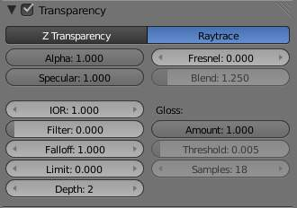
The Transparency Panel.
In addition to the common options given above, the following property controls are available:
IOR
Index of Refraction. Sets how much a ray traveling through the material will be refracted, hence producing a distorted image of its background. See IOR values for Common Materials below.
Filter
Amount of filtering for transparent ray trace. The higher this value, the more the base color of the material will show. The material will still be transparent but it will start to take on the color of the material. Disabled (0.0) by default.
Falloff
How fast light is absorbed as it passes through the material. Gives ‘depth’ and ‘thickness’ to glass.
Limit
Materials thicker than this are not transparent. This is used to control the threshold after which the filter color starts to come into play.
Depth
Sets the maximum number of transparent surfaces a single ray can travel through. There is no typical value. Transparent objects outside the Depth range will be rendered pitch black if viewed through the transparent object that the Depth is set for. In other words, if you notice black areas on the surface of a transparent object, the solution is probably to increase its Depth value (this is a common issue with ray tracing transparent objects). You may also need to turn on transparent shadows on the background object.
Gloss
Settings for the glossiness of the material.
Amount
The clarity of the refraction. Set this to something lower than zero to get a blurry refraction.
Threshold
Threshold for adaptive sampling. If a sample contributes less than this amount (as a percentage), sampling is stopped.
Samples
Number of cone samples averaged for blurry refraction.

Examples

Index of Refraction
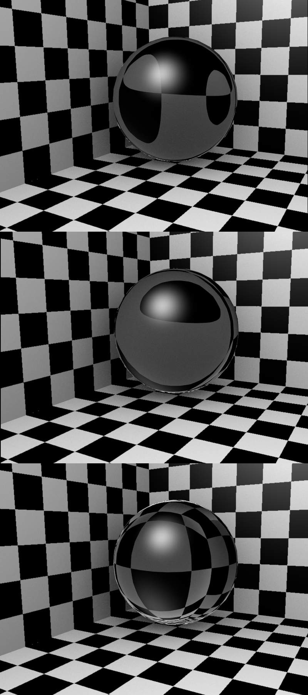
Influence of the IOR of an Object on the distortion of the background: spheres of Water, Glass and Diamond (top to bottom).
(Influence of the IOR of an Object on the distortion of the background: spheres of Water, Glass and Diamond (top to bottom).). There are different values for typical materials: Air is 1.000 (no refraction), Alcohol is 1.329, Glass is 1.517, Plastic is 1.460, Water is 1.333 and Diamond is 2.417.

Fresnel
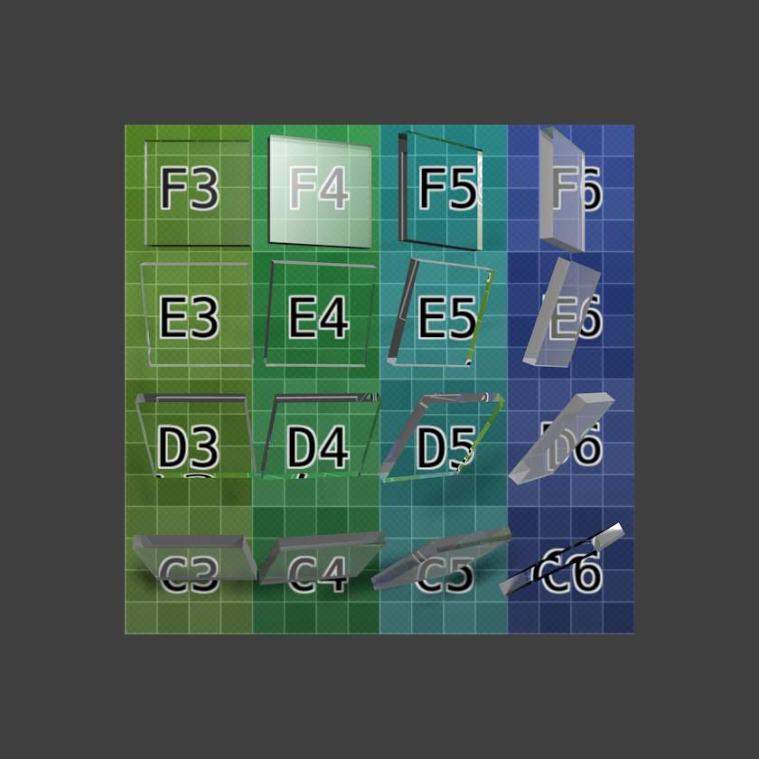 | 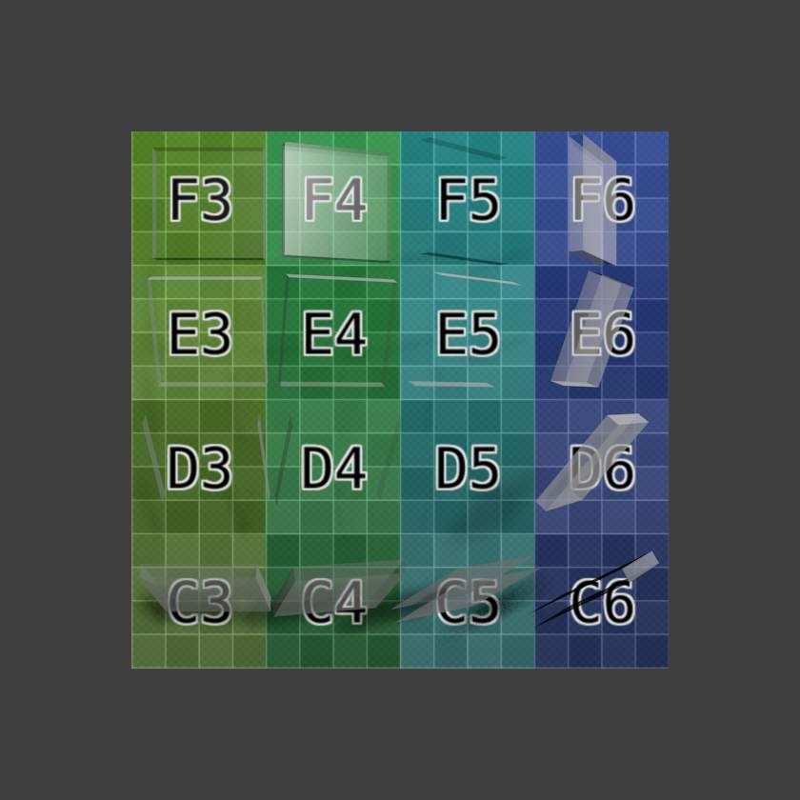
16 pieces of glass rotated in various directions demonstrate the angle-dependent Fresnel effect with ray-traced (left) and alpha buffered transparency (right). Note that the major difference is the lack of IOR effect in the latter case. (Download .blend.)
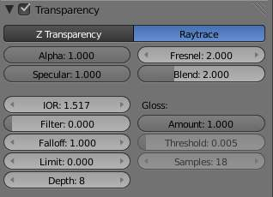 | 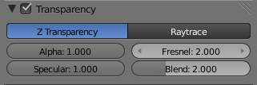
Settings for Fresnel using ray-traced (left) and Z transparency (right).
Note the specular highlight in the F4 glass tile (which is facing midway between the light and the camera); the Fresnel effect can be seen in row C and column 6 where the faces are turned away from the camera.
The amount of Fresnel effect can be controlled by either increasing the Blend value or decreasing the Alpha value.

Depth
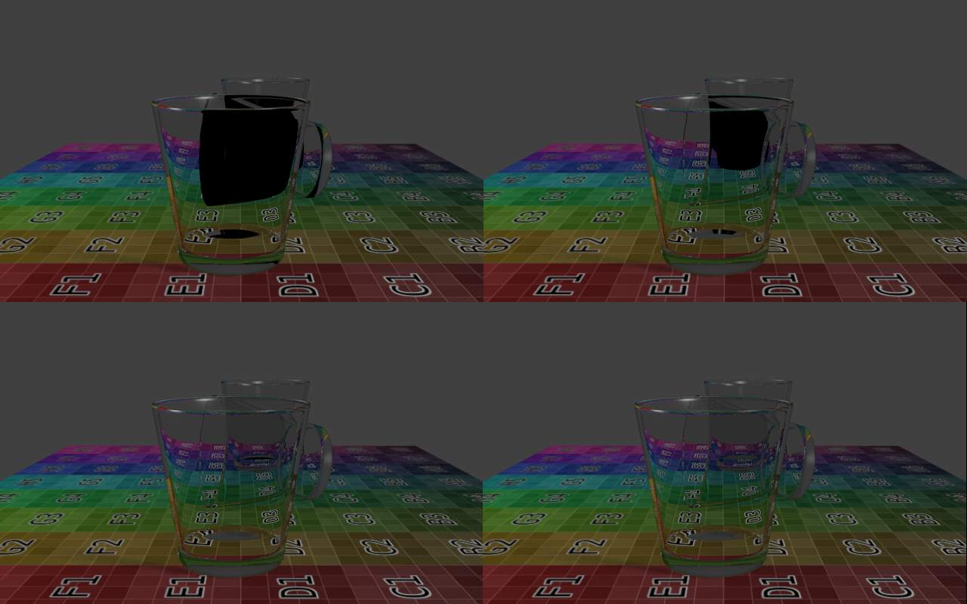
A simple scene with three glasses on a surface, and three lamps. Depth was set to 4, 8, 12, and 14, resulting in render times of 24 sec, 34 sec, 6 min, and 11 min respectively. (Download .blend.)
Increasing Depth also considerably increases render time. Each time a light ray passes through a surface, the ray-tracing algorithm is called recursively. In the example above, each side of each glass has an exterior and an interior surface. Light rays thus have to pass through four surfaces for each glass.
But not only that, at every point on a surface, some of the light can be reflected, or mirrored off the surface in various directions. This results in multiple rays needing to be calculated for each point (often referred to as a tree of rays). In each of the rendered images above there are 640×400=256 000 pixels. By increasing Depth, at least one tree of rays is added to each pixel.
Be kind to your computer. Carefully placing objects in a scene to avoid overlapping transparent objects is often an interesting alternative.

Hints

Transparent shadows
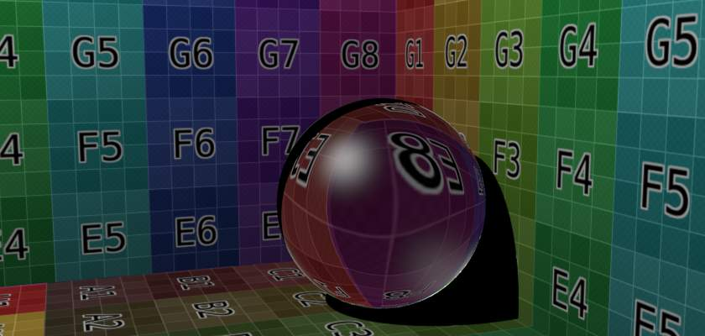  No transparent shadows | 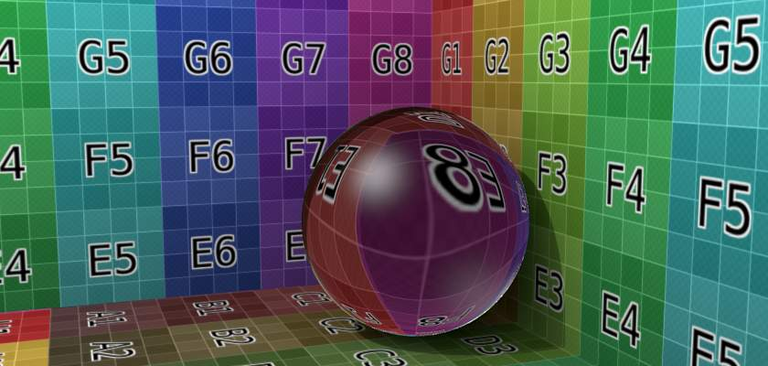  No transparent shadows, environment lighting enabled
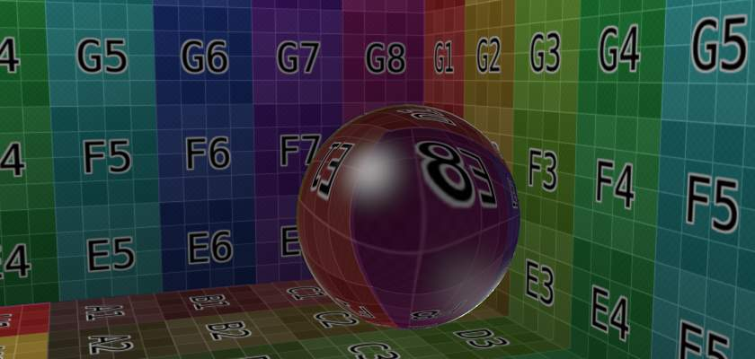  Transparent shadows enabled, alpha set to 0.0 | 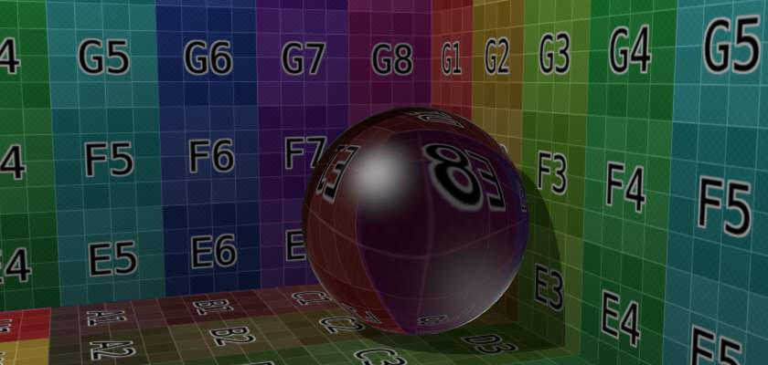  As previous, alpha set to 0.25
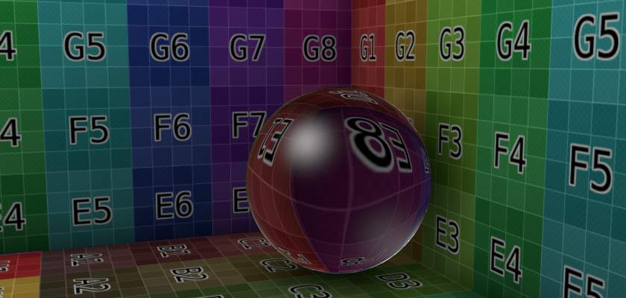  Transparent shadows with ambient occlusion set to multiply, distance 1 (radius of sphere) | 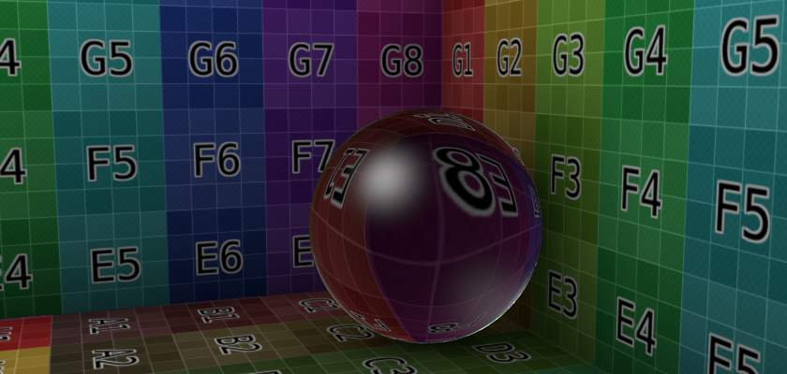  As previous, distance increased to 2 (diameter of sphere)
By default, the shadows of transparent objects are rendered solid black, as if the object was not transparent at all. But in reality, the more transparent an object is, the lighter its shadow will be.
In Bforartists, transparent shadows are set on the materials that receive the shadows from the transparent object. This is enabled and disabled with the Receive Transparent button, in the Material context –> Shadow panel. The shadow’s brightness is dependent on the Alpha value of the shadow casting material.
Alternatives to transparent ray-traced shadows can be found in the World context, namely the Ambient Occlusion, Environment Lighting, and Gather panels. Alternatively, a texture can be used to control the Intensity value of the shadow-receiving material.

IOR values for Common Materials
The following list provides some index of refraction values to use when ray-traced transparency is used for various liquids, solids (gems), and gases:

Gasses
- Air 1.000 | - Carbon Dioxide 1.000449 | - Oxygen 1.000276

Common Liquids
- Alcohol 1.329  - Milk 1.35  - Oil, vegetable (50- C) 1.47  - Shampoo 1.362 | - Water (0- C) 1.33346  - Water (100- C) 1.31766  - Water (20- C) 1.33283 | - Water (gas) 1.000261  - Water (35- C, room temp) 1.33157  - Vodka 1.363

Common Transparent Materials
- Glass 1.51714 | - Ice 1.309 | - Rock Salt 1.544

Common Opaque Materials
- Asphalt 1.635  - Chalk 1.510 | - Plastic 1.46  - Rubber, Natural 1.5191 | - Silicon 4.24

Gemstones
- Diamond 2.417  - Jade, Nephrite 1.61 | - Opal 1.45 | - Ruby 1.757 - 1.779

Metals
- Aluminum 1.44  - Bronze 1.18  - Copper 1.10  - Gold 0.47 | - Iron 1.51  - Lead 2.01  - Platinum 2.33 | - Silver 0.18  - Steel 2.50  - Titanium 2.16

Mirror Reflections

Mirror reflections are computed in the Bforartists Render and Cycles render engines using ray tracing. (NB: Reflections are not available in the Game Engine.) Ray tracing can be used to make a material reflect its surroundings, like a mirror. The principle of ray-traced reflections is very simple: a ray is fired from the camera and travels through the scene until it encounters an object. If the first object hit by the ray is not reflective, then the ray takes the color of the object. If the object is reflective, then the ray bounces from its current location and travels up to another object, and so on, until a non-reflective object is finally met and gives the whole chain of rays its color.
Eventually, the first reflective object inherits the colors of its environment, proportional to its Reflectivity value. Obviously, if there are only reflective objects in the scene, then the render could last forever. This is why a mechanism for limiting the travel of a single ray is set through the Depth value: this parameter sets the maximum number of bounces allowed for a single ray.
Note
You need to enable ray tracing in your scene settings if you want to use ray-traced reflections. This is done in the Scene/Render context –> Render Panel. Ray tracing is enabled by default in Bforartists 2.37 and higher.

The Color Swatch in the mirror panel is the color of the light reflected back. Usually, for normal mirrors, use white. However, some mirrors color the reflection (e.g. metals), so you can change the color by clicking on the swatch. The amount of mirrored reflection is determined by the Reflectivity value. If set to something greater than 0, mirrored reflectivity will be activated and the reflection will be tinted the color set in the swatch.

Options
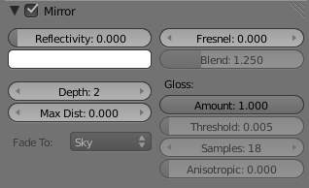
The Mirror Panel
Enable ray-traced reflections
Enable or disable ray-traced reflections
Reflectivity
Sets the amount of reflectiveness of the object. Use a value of 1.0 if you need a perfect mirror, or set it to 0.0 if you don’t want any reflection.
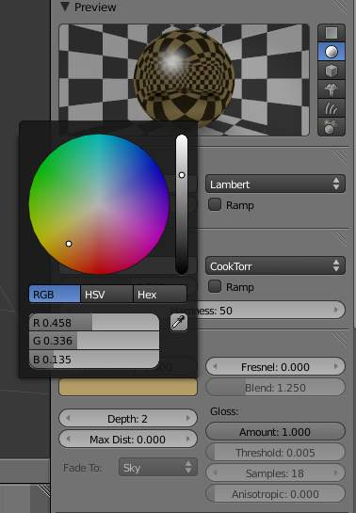
Picking a mirror color
Color swatch
Color of mirrored reflection By default, an almost perfectly reflective material like chrome, or a mirror object, will reflect the exact colors of its surrounding. But some other equally reflective materials tint the reflections with their own color. This is the case for well-polished copper and gold, for example. In order to replicate this within Bforartists, you have to set the Mirror Color accordingly. To set a mirror color, simply click the color swatch in the mirror panel and select a color.
Fresnel
Sets the power of the Fresnel effect. The Fresnel effect controls how reflective the material is, depending on the angle between the surface normal and the viewing direction. Typically, the larger the angle, the more reflective a material becomes (this generally occurs on the outline of objects).
Blend
A controlling factor to adjust how the blending happens between the reflective and non-reflective areas.
Depth
Maximum allowed number of light inter-reflections. If your scene contains many reflective objects and/or if the camera zooms in on such a reflective object, you will need to increase this value if you want to see surrounding reflections in the reflection of the reflected object (!). In this case, a Depth of 4 or 5 is typically a good value.
Max Dist
Maximum distance of reflected rays away from camera (Z-Depth) in Bforartists units. Reflections further than this range fade out to reduce compute time.
Fade to
The color that rays with no intersection within the Max Distance take. Material color can be best for indoor scenes, Sky color (World settings) for outdoor scenes.
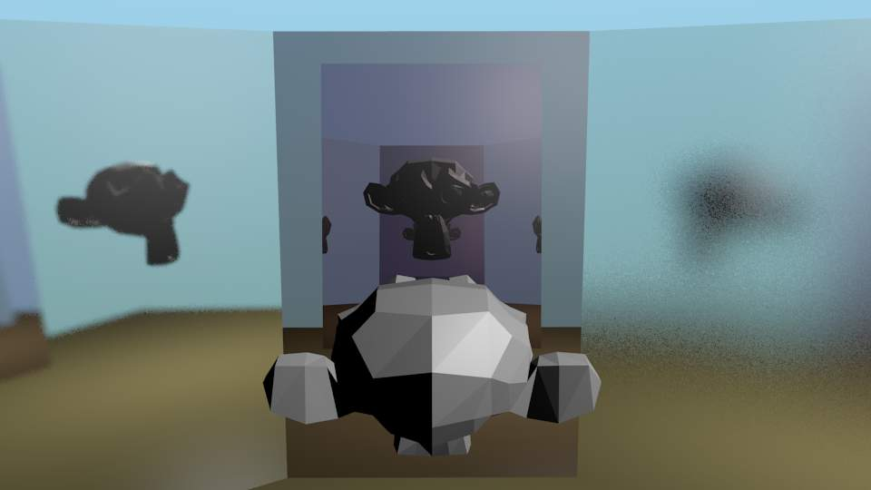
Suzanne in the Fun House (.blend)
Gloss
In paint, a high-gloss finish is very smooth and shiny. A flat, or low gloss, finish disperses the light and gives a very blurry reflection. Also, uneven or waxed-but-grainy surfaces (such as car paint) are not perfect and therefore slightly need a Gloss < 1.0. In the example to the right, the left mirror has a Gloss of 0.98, the middle is Gloss = 1.0, and the right one has Gloss of 0.90. Use this setting to make a realistic reflection, all the way up to a completely foggy mirror. You can also use this value to mimic depth of field in mirrors.
Amount
The shininess of the reflection. Values < 1.0 give diffuse, blurry reflections and activate the settings below.
Threshold
Threshold for adaptive sampling. If a sampling contributes less than this amount (as percentage), sampling is stopped. Raising the threshold will make the adaptive sampler skip more often, however the reflections could become noisier.
Samples
Number of cone samples averaged for blurry reflection. More samples will give a smoother result, but will also increase render time.
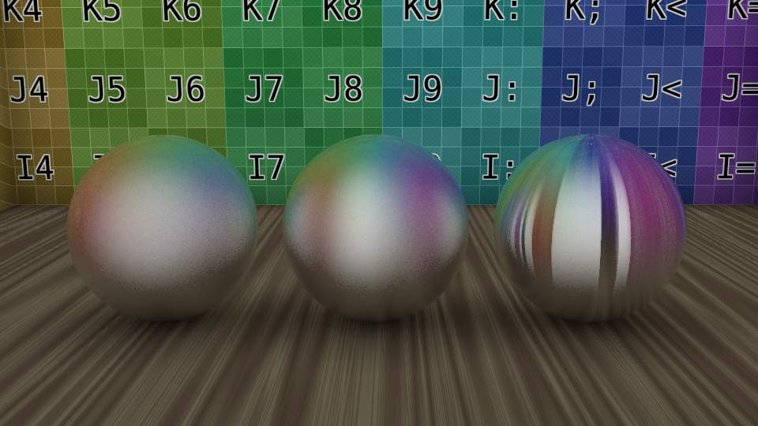
Anisotropic tangent reflecting spheres with anisotropic set to 0.0, 0.75, 1.0. (.blend)
Anisotropic
The shape of the reflection, from 0.0 (circular) to 1.0 (fully stretched along the tangent). If the Tangent Shading is on, Bforartists automatically renders blurry reflections as anisotropic reflections. When Tangent is switched on, the Anisotropic slider controls the strength of this anisotropic reflection, with a range of 1.0 (default) being fully anisotropic and 0.0 being fully circular, as is when tangent shading on the material is switched off. Anisotropic ray-traced reflection uses the same tangent vectors as for tangent shading, so you can modify the angle and layout the same way, with the auto-generated tangents, or based on the mesh’s UV co-ordinates.

Examples

Fresnel
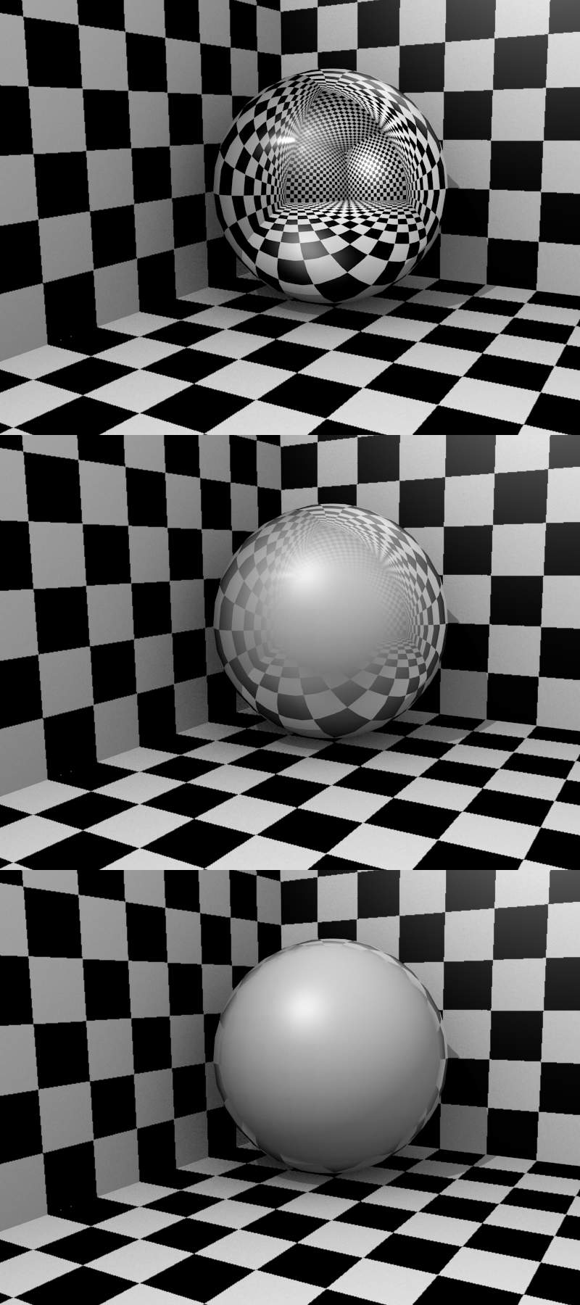
Demonstration of Fresnel effect with values equal to (from top to bottom) 0.0, 2.5 and 5.0
Let’s undertake a small experiment in order to understand what Fresnel is really about. After a rainy day, go out and stand over a puddle of water. You can see the ground through the puddle. If you kneel just in front of the puddle, your face close to the ground, and look again at a distant point on the puddle of water, the liquid surface part which is closer to you lets you see the ground, but if you move your gaze towards the other end of the puddle, then the ground is gradually masked until all you see is the reflection of the sky. This is the Fresnel effect: having a surface sharing reflective and non-reflective properties according to the viewing angle and the surface normal.
In Demonstration of Fresnel effect with values equal to (from top to bottom) 0.0, 2.5 and 5.0, this behavior is demonstrated for a perfectly reflective Material (Mirror Reflectivity 1.0).
Fresnel 0.0 stands for a perfect mirror Material, while Fresnel 5. 0 could stand for a glossy Material. It’s barely noticeable but in the lower picture, the Material is perfectly reflective around the edges.
The smoothness of the Fresnel limit can be further controlled using the Blend slider.

Subsurface Scattering

Many organic and inorganic materials are not totally opaque right at the surface, so light does not just bounce off the top surface. Instead, some light also penetrates the skin surface deeply, and scatters around inside, taking on the color of the insides and emerging back out at a different location. Human/animal skin, the skin of grapes, tomatoes, fruits, wax, gels (like honey, or Jello) and so on all have subsurface scattering (SSS), and photo-realism really cannot be achieved without it.
It is important to understand that subsurface scattering and diffuse are one and the same. The difference is in how far light can diffuse beneath the surface before it is absorbed or transmitted back out.

How it works
Actually calculating the light path beneath the surface of an object is not practical. But it has been shown that it is not necessary to do this, and that one can use a different approach.
Bforartists calculates SSS in two steps:
- At first the irradiance, or brightness, of the surface is calculated, from the front side of the object as well as from its back side. This is pretty much the same as in a normal render. Ambient Occlusion, Radiosity, the type of diffuse Shader, the light color, etc. are taken into account.
- In the second step, the final image is rendered, but now the SSS shader replaces the diffuse shader. Instead of the lamps, the calculated lightmap is used. The brightness of a surface point is the calculated “Average” of the brightness of its surrounding points. Depending on your settings the whole surface may be taken into account, and it’s a bit more complicated than simply calculating the average, but don’t bother too much with the math behind it.
Instead let’s see what SSS does to a distinct light point.
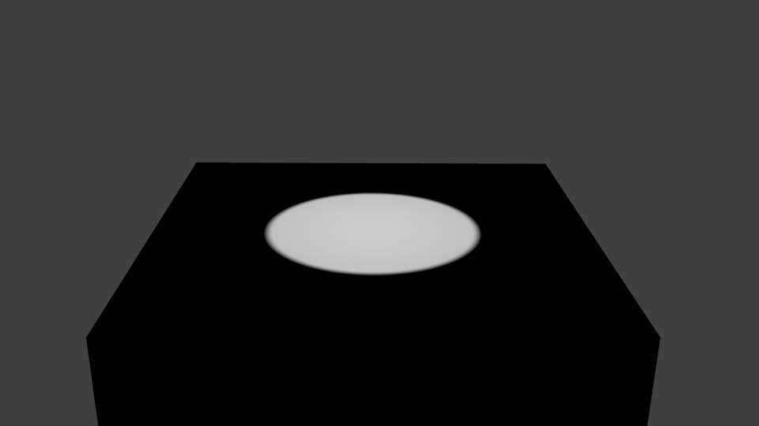  Image 3a: No SSS. | 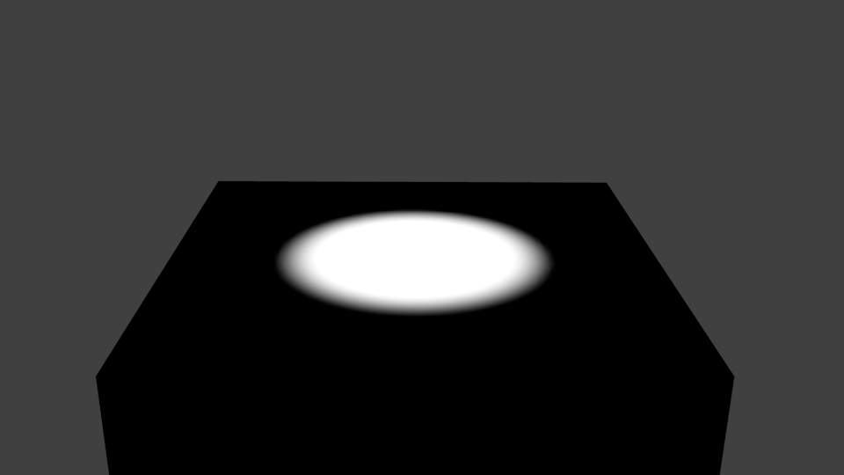  Image 3b: Small SSS radius.
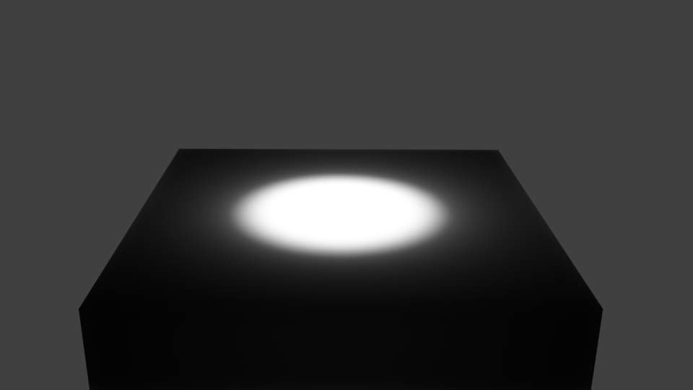  Image 3c: SSS radius enlarged. | 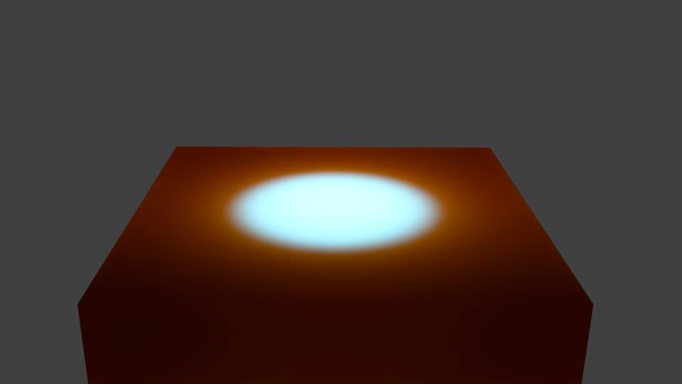  Image 3d: SSS with very large red radius value.
If you turn on SSS, the light is distributed over a larger area. The size of this area depends on the radius values. Instead of distributing all colors with the same amount, you may choose different radius values for each of the RGB colors.
If you use a very large radius value for a color, its light is evenly distributed over the whole object.
Note
Note about scatter radius
Because of the way this scattering is calculated, when using large radius values, you will notice fringing artifacts that appear as the complementary color to the predominant color of the scattering. Above, you see in the last image a bluish band in the illuminated area. This is an unfortunate limitation. A way to lessen this effect is use multiple passes with different scatter radii, and average them.

Enabling Subsurface Scattering
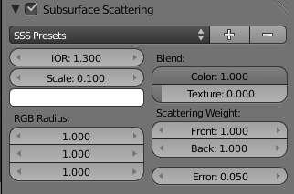
Image 4: The SSS Panel. SSS is already enabled.
- Enable SSS by clicking on the Subsurface Scattering button.
- Accessible at the top are various presets. Add new or remove old presets by clicking the + and - buttons. When you select a preset, the Radius values, the RGB Radius and the IOR are set for you. The remaining options are not set (because they are mostly dependent on the size of your object).
SubSurface Scattering doesn’t need ray tracing. But since it is dependent on the incident light and shadows, [you need proper shadow calculation (which may need ray tracing).

Options
The numeric sliders control how the light is scattered:
IOR
The Index Of Refraction value determines the falloff of incident light. Higher values means that light falls off faster. The effect is quite subtle and changes the distribution function only a little bit. By the examination of many different materials, values of 1.3 to 1.5 have been found to work well for most materials. If you know the exact material you are trying to simulate, see IOR values for Common Materials.
Scale
The scale of your object, in Bforartists units, across which you want the scattering effect to take place. Scale 1.0 means 1 Bforartists unit equals 1 millimeter, scale 0.001 means 1 Bforartists unit equals 1 meter. If you want to work out what scale value to use in your scene, just use the formula: (size in Bforartists units)/(real world size in millimeters)=scale.
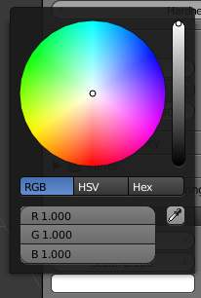
The SSS Color Swatch
Scattering Color (Albedo)
Albedo is the probability that light will survive a scattering event. If you think of scattering as a filter, this is the height of the filter. It is multiplied by the surface color. In practice, this is unintuitive. It should be the same as the surface color, however changing this value has unintuitive results on the scattering effect:
The darker the color the more light is scattered. A value of 1 will produce no scattering effect.
So if you set it to green, the lit areas of the object will appear as green, and green is scattered only a little. Therefore the darker areas will appear in red and blue. You can compensate the different scattering by setting a larger radius for the color.
RGB Radius
This is not in fact the radius of the subsurface scattering, but the average path length between scattering events. As the light travels through the object it bounces around then emerges from the surface at some other point. This value corresponds to the average length the light travels between each bounce. The longer the path length is, the further the light is allowed to scatter. This is the main source of a material’s perceived “scatter color.” A material like skin will have a higher red radius than green and blue. Subsurface scattering is the diffusion of light beneath the surface. You control how far the light spreads to achieve a specific result.
Blend :
Color
This controls how much the R, G, B option modulates the diffuse color and textures. Note that even with this option set to 0.0, the R, G, B option still influences the scattering behavior.
Texture
How much the surface texture is blurred along with the shading.
Scattering Weight :
Front
Factor to increase or decrease the front scattering. When light enters through the front of the object, how much is absorbed or added? (Normally 1.0 or 100%).
Back
Factor to increase or decrease the back scattering. Light hitting an object from behind can go all the way through the object and come out on the front of the object. This happens mostly on thin objects, like hands and ears.
Error
This parameter controls how precisely the algorithm samples the surrounding points. Leaving it at 0.05 should give images without artifacts. It can be set higher to speed up rendering, potentially with errors.
Setting it at 1.0 is a good way to quickly get a preview of the look, with errors.

Developing your own SSS material

The Traditional Approach
A more common but less intuitive approach is to use “layering”. This is a simplified version of the layering approach. See the external links for more information:
- Set the SSS color on a value of your choice, normally the predominant color of the object. If you want to use different radii for the colors, don’t make it too dark.
- Set the scale factor. If you want to see much translucency you need small objects or large scale values.
- Set the radius values.
- Adjust the brightness with the Front and Back values.

A more intuitive approach
- Set the Scattering color to .5
- Set the Front weight to 2.
- Set the scale factor based on the size of your object relative to the scene. If you want to see much translucency you need small objects or large scale values.
- Set the radius values appropriately.

Examples

Skin

Increasing SSS scale (.blend)
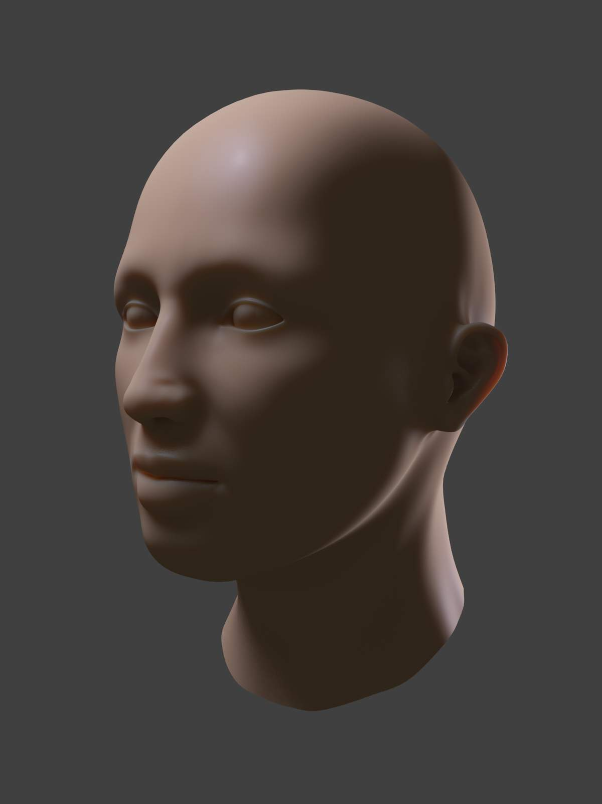  1 | 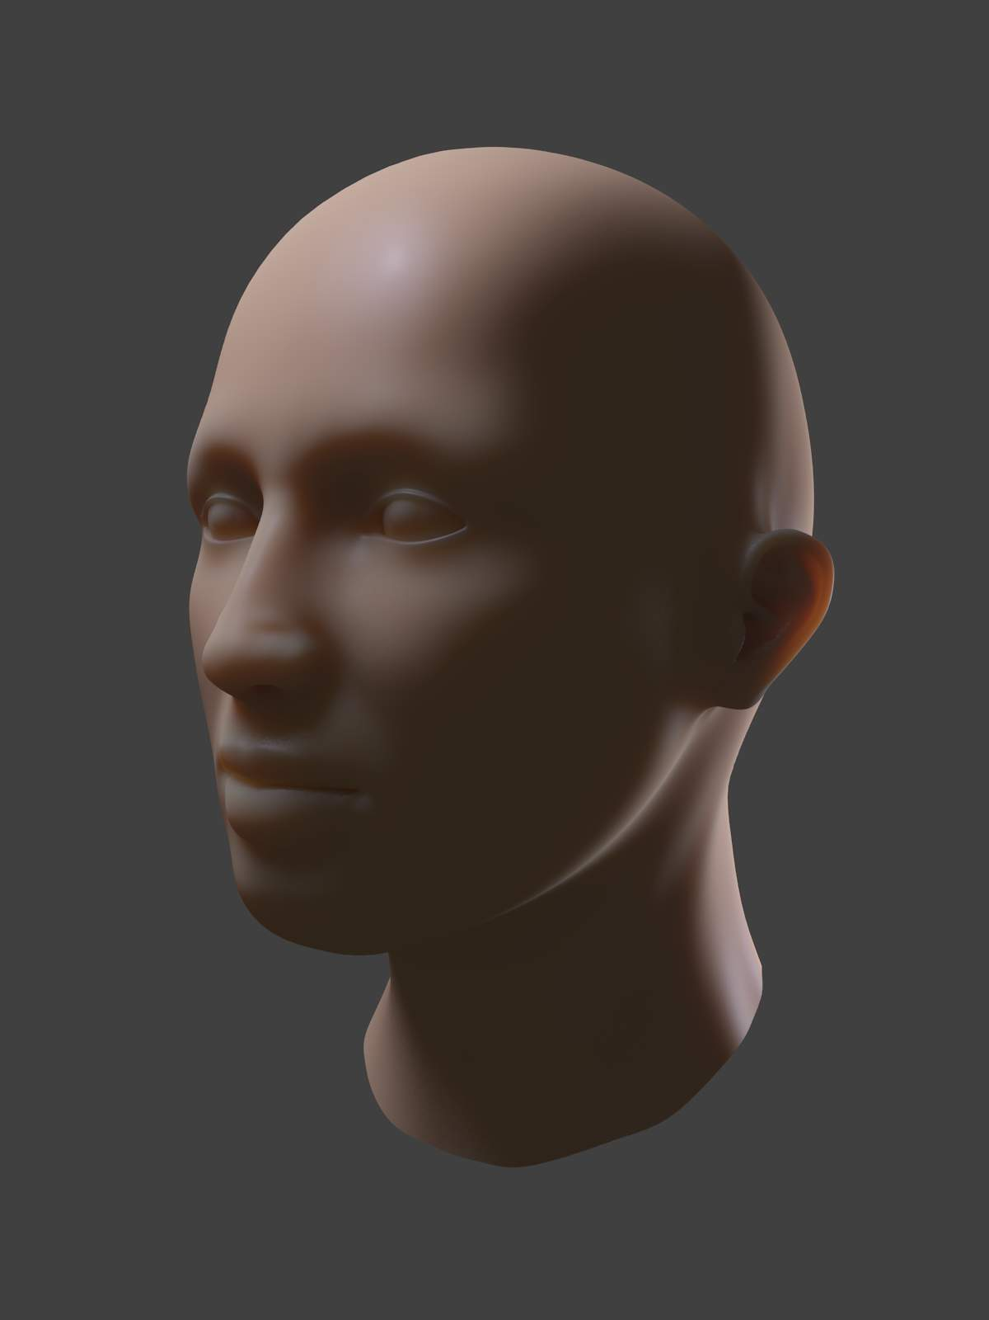  2 | 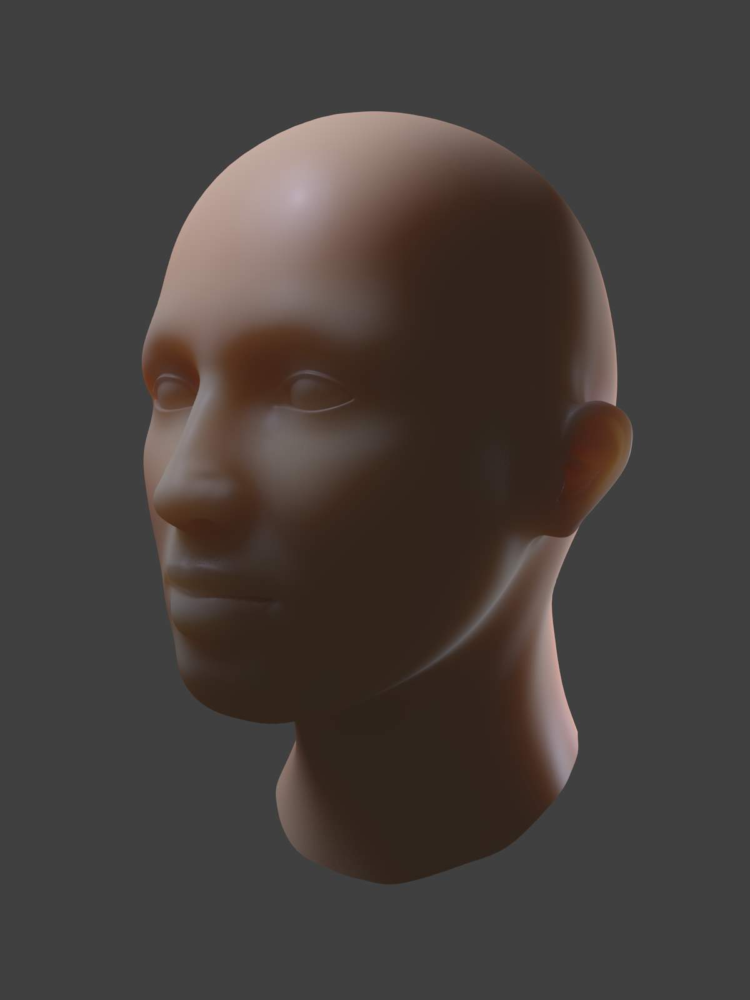  3 | 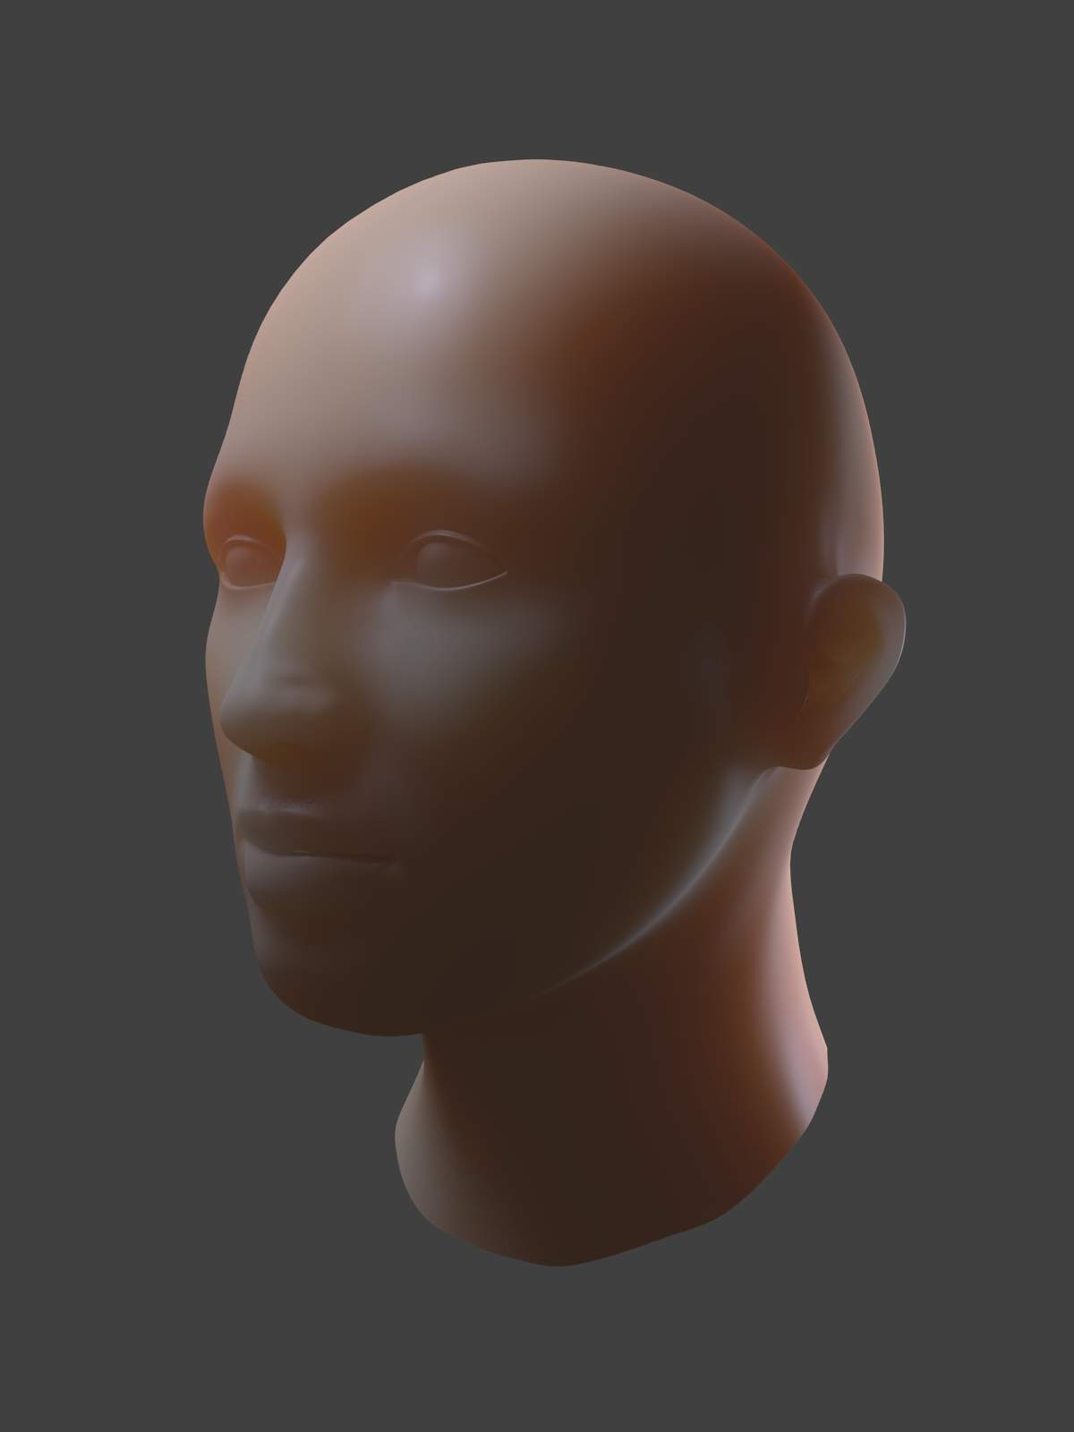  4 | 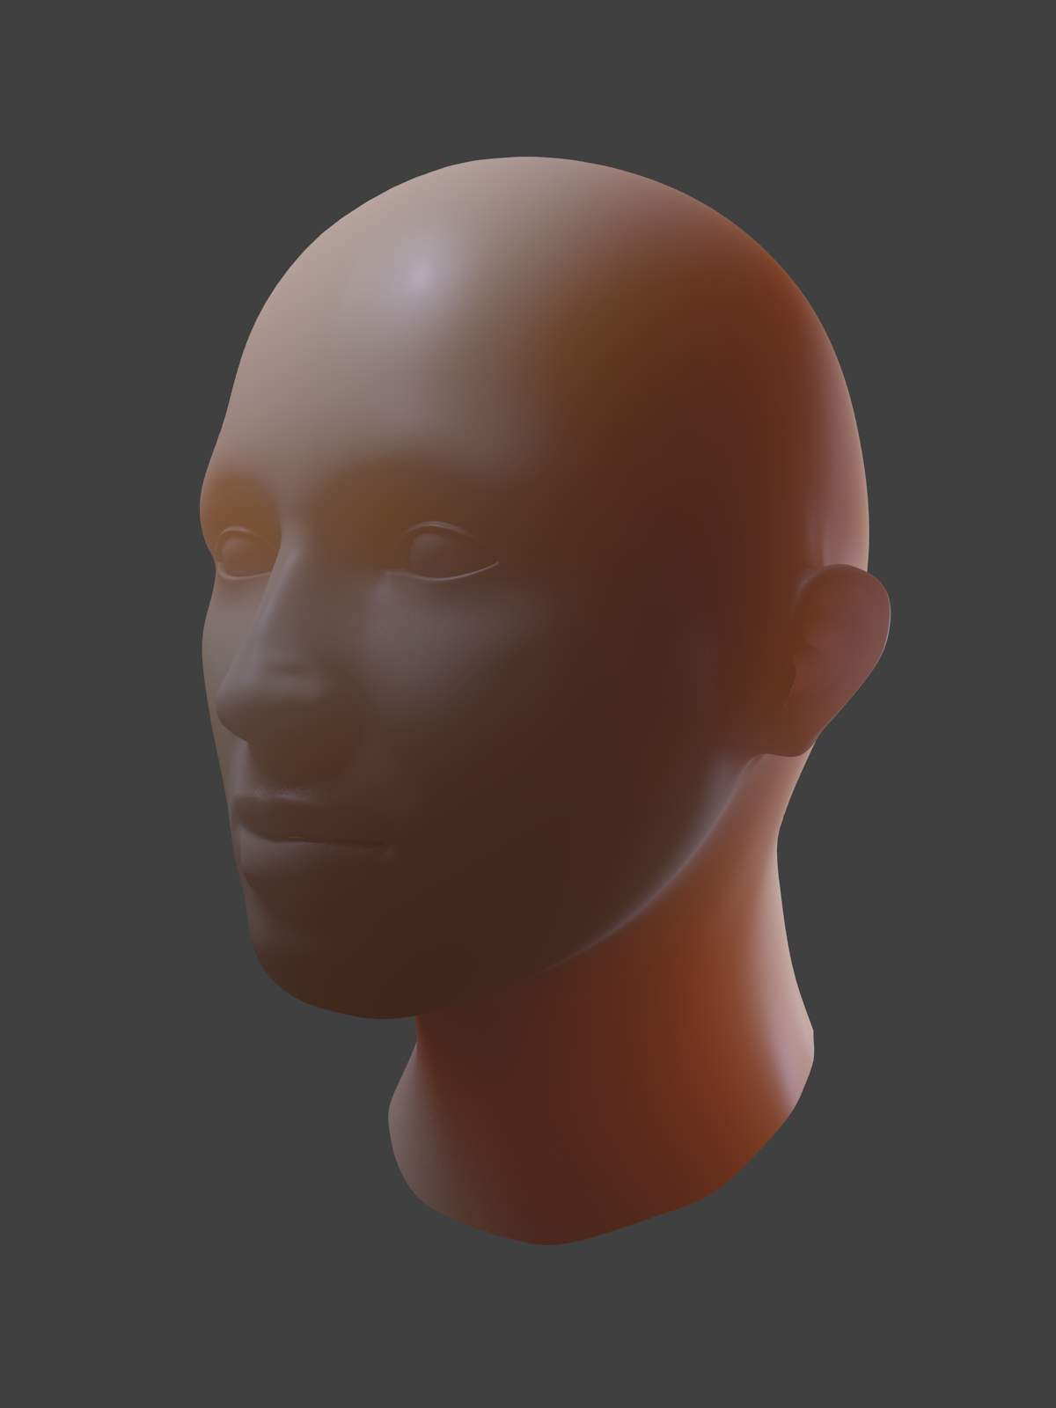  5

See also
- Development Release Log: Subsurface Scattering
- Ben Simonds: Three Layer SSS in Bforartists Demystified

Strands

The Strand section of the Material editor is specific to the rendering of Hair particles. There are two different strand methods available:
Polygon strands
This is the default (old) method. The strands are rendered as flat polygons. The number of polygons depend on the Steps settings in the Render panel of the Object context, Particles sub-context.
Strand Primitive
You activate Strand Primitive with the button Strand render in the Render panel of the particle system. The hair curves are not stored as polygons; only the key points are stored, which are then converted to polygons on the fly. A second difference is the way transparency works. Rather than rendering using the existing system, all strand segments in a part are sorted front to back and rendered in that order.
Strand Primitives:
- Are more memory efficient and faster, to make rendering of large amounts of fur and grass possible. For good performance, the render steps button should be lowered (e.g. 2 should be good enough fur), since the result will be a smoothed curve anyway. You need 1 to 2 render steps less than steps in the 3D window. Also, using more render parts helps to reduce memory usage.
- Have a distance of vision reduction (in the Render panel under Child Simplification) for children from faces.
- May be faded out towards the tip without an additional texture.
- Are not ray traced. So they are not visible through ray-transparent materials or in a ray mirror (you can use Environment Mapping for that).
- Have shape problems if they are rendered with a greater width.
- Cannot carry a UV-Texture along the strand.
Polygon strands:
- Work well with greater width, so you can use them as an alternative to billboards because the strands may have an animated shape.
- Can be textured with a UV-Texture along the strands.
- Are seen by ray tracing.

Strands Shading
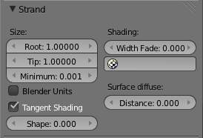
Image 1: Strands Panel.
Strands are rendered with the material of the underlying face/vertex, including shading with a UV-Texture. Since you can assign more than one material to each face, each particle system may have its own material and the material of the underlying face can be different from the material of the strands.
Additionally strands can be shaded along the strand (from root to tip) with a mono-dimensional texture; only polygon strands can carry a two-dimensional UV-Texture.
The options for strand shading are in the Strands section of the Material context.
Root
Width of the hair at the root.
Tip
Width of the hair at the tip.
Minimum
This is the minimum thickness (in pixels) of the strands. Strands below that size are not rendered smaller, but are faded to alpha (well, the fading works only for strand primitives). This gives a much better rendering result for thin hair.
Bforartists Units
Normally strands are quite thin; the thickness is given in screenpixels. If you use Bforartists units (BU) you may set the root value up to 2 BU, and the tip value up to 1 BU. You have to consider the overall object size, because the smallest possible size is 0.001 BU. So if you use 1 BU for 1 meter the smallest possible size would be 1 mm (too thick for thin hair).
Use Tangent Shading
Calculates the light as if the strands were very thin and round. This makes the hair appear brighter and shinier. Disabling the “Tangent Shading” option will still render nicely, but resembles more solid strands, as though made of metal or wood.
Shape
This slider allows you to control the interpolation. Default (0.0) is a linear interpolation between Root and Tip. A negative value will make the strand narrower (spiky), a positive value will make it fatter.
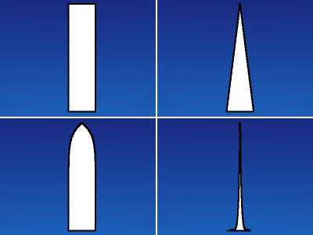
Width Fade
To fade out along the width of the strand. This works only for Strand Primitives. 0.0 is no fading at all, 1.0 linear fading out.
UV Layer
You can texture polygon strands with a UV-Texture. Fill in the name of the UV-Set (not the texture) here. You also have to load the texture in the Shading context, Texture and Material sub-contexts (Mapping: UV; you may use every Influence setting you like - especially the alpha value; see Image 3).
Surface Diffuse
Computes the strand normal, taking the normal at the surface into account. This eases the coloring and lighting of hair a lot, especially for Strand Primitives. Essentially hair reacts similar to ordinary surfaces and don’t show exaggerated strong and large specular highlights.
Distance
The distance in Bforartists units over which to blend in the normal at the surface (if you want to use Surface Diffuse only for Grass/Fur at greater distances).

Texturing along the Strand
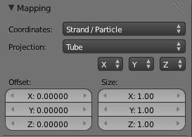
Image 4: Fading a strand to alpha...

Image 5: ...And the render result.
Strands can be textured along the strand, i.e. from root to tip. To do that you have to select Strand/Particle in the Coordinates drop-down in the Mapping panel of the Material sub-context.
Pretty much the most important setting is shown in (Image 4), how to fade the tip of a strand to alpha to make nice, fuzzy-looking hair. Normally you would use a linear blend texture for this.
You may of course set any attribute you like, especially color. Be careful with specularity; hairs tend to get too shiny.

Strand render Simplification
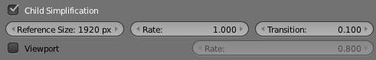
Image 5: Strand render child simplification.
If you use Strand Primitives (Strand render button) and have activated Interpolated Children, the Child Simplification option appears. The strand render has options to remove child strands as the object’s faces become smaller.
Reference Size
This is the approximate size of the object on screen (in pixels), after which simplification starts.
Rate
How fast strands are removed.
Transition
The transition period for fading out strands as they are removed.
Viewport
This removes strands on faces that are outside of the viewport.
Rate
Controls how fast these are removed.

Options

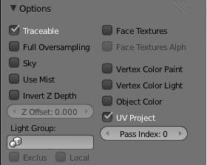
Material Options Panel
This panel provides a series of control options concerning how objects using this material will appear in the rendered image. All controls are default “Off” unless otherwise stated.
Traceable (default On)
Include this material and the geometry that uses it in ray-tracing calculations. See Transparency for details of ray-tracing.
Full Oversampling
Force this material to render full shading/textures for all anti-aliasing samples.
Sky
Render this material with zero alpha, but with sky background in place (scanline only)
Use Mist
Use mist on this material (see “World Settings” for more details)
Invert Z depth
Render material’s faces with an inverted Z buffer (scanline only)
Z Offset
Give faces an artificial Z offset for Z transparency.
Light Group
Limit lighting to lamps in this light group.
Exclusive
Uses the light group exclusively - these lamps are excluded from other scene lighting
Local
When linked in, uses local light group with the same name.
Face Textures
Replace object’s base color with color from UV map image textures.
Face Textures Alpha
Replace object’s base alpha with alpha from UV map image textures.
Vertex Color Paint
Replace object’s base color with vertex paint colors (multiply with ‘texture face’ face assigned textures)
Vertex Color Light
Add vertex paint colors as additional lighting. (This can be used to produce good incandescence effects).
Object Color
Modulate the result with a per object color
UV Project (default On)
Use to ensure UV interpolation is correct for camera projections (use with UV project modifier).
Pass Index
Index number for the IndexMA render pass.

Shadows

The shadows that appear in a scene are affected by a combination of the layout of objects, the shape of the objects, the materials of the objects, and the lighting. In Bforartists, the Display Mode (Single Texture, Multitexture,or GLSL) also affects the appearance of shadows. See Shadows for a more complete description of this subject.
Tip
Shadows in 3D mode
To see shadows in 3D (textured) mode, you must have switched to GLSL mode before making any materials. In MultiTexture mode, shadows only appear in the rendered image: none of these can be seen in the preview image.

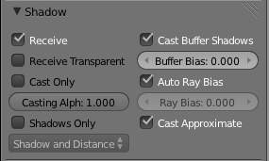
Fig. 1: Shadow Panel.
The Shadow panel in the Materials Properties window (Fig. 1) controls the effects that the material can have on the shadows that appear in the scene. The various properties are described in the sections below.
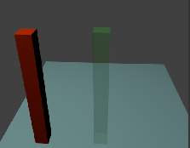
Fig. 2: Scene- all shadow properties off.

Options
The following properties can be set for each individual material with which objects in the scene are shaded. The effects are illustrated with rendered images for a simple scene (Fig. 2) consisting of two “posts”, one with a red (totally non-transparent) material; one green (partially transparent) material, set up on a light blue plane to receive the shadows. The illustrations were all taken in Bforartists Render engine, with Multitexture mode.

Shadow Receiving Object Material
The following options affect the material that receives shadows:
Receive
Allows this material to receive full-intensity shadows (Fig. 3).
Receive Transparent
Allows this material to receive shadows whose intensity is modified by the transparency and color of the shadow-casting object (Fig. 4).
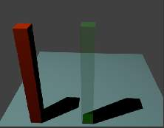
Fig. 3: Plane - Receive.
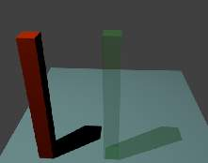
Fig. 4: Plane - Receive + Receive Transparency.

Shadow Casting Object Material
The following options affect the material that casts shadows:
Cast Only
Material appears transparent, but it still casts shadows (Fig. 5).
Casting Alpha
??
Shadows Only
Material appears transparent except for where it receives shadows from other objects, and also it retains its own transparency (Fig. 6). Note the faint image of the partly-transparent post.
Shadow and Distance
???
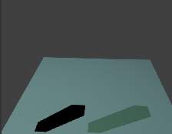
Fig. 5: Posts - Cast Only.
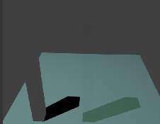
Fig. 6: Posts - Shadows Only.

Buffered Shadow Options
In addition to the shadow options described above, there are further material properties which control buffered shadow features. See section on Spot Buffered Shadows for further discussion of these techniques.
Cast Buffer Shadow
Casts shadows from shadow buffer lamps.
Buffer Bias
Multiplication factor for Buffer shadows (0 = ignore)
Auto Ray Bias -
Prevent raytraced shadow errors on surfaces with smooth shaded normals.
Ray Bias
Bias value to be used.
Cast Approximate
Allow this material to cast shadows when using approximate ambient occlusion.

Introduction to Material Nodes

In addition to creating materials as just described using all the settings on all the materials panels, Bforartists allows you to create a material by routing basic materials through a set of nodes. Each node performs some operation on the material, changing how it will appear when applied to the mesh, and passes it on to the next node. In this way, very complex material appearances can be achieved.
You should already be familiar with general material concepts and how to create materials/textures using the material menu. You should also have a general understanding of the texture coordinate systems available in Bforartists (e.g. Generated, UV, etc.). Also, many aspects of a node will be skipped here because in later sections you will see the function expanded upon. Each section builds off the previous.
To start, the node system does not make the material menu obsolete. Many features and material settings are still only accessible through the material panel (e.g. Ray Mirror). However with the advent of nodes, more complex and fantastic materials can be created since we now have greater control.
Just in case you’re not (yet) familiar with the concepts: when you create a system of nodes (otherwise known as a “noodle”), you’re describing a data-processing pipeline of sorts, where data “flows from” nodes which describe various sources, “flows through” nodes which represent various processing and filtering stages, and finally “flows into” nodes which represent outputs or destinations. You can connect the nodes to one another in many different ways, and you can adjust “knobs, ” or parameters, that control the behavior of each node. This gives you a tremendous amount of creative control. And, it will very quickly become intuitive.
Having said all that, let’s begin with a normal material.
Here we have the standard material we have added to a cube mesh. We could, as we have in the past, add color and other settings to this material and it would certainly look nice. But let’s say we are just not getting what we are looking for? What if we want to control the creation more tightly or add more complexity? Here is where nodes come in.
Making this node map is accomplished by working in a Node Editor window. This section covers:
- Enabling Material Nodes.
- The Node Editor window, its basic controls, and working with nodes.
- The specific types of nodes available for materials.

Accessing The Node Editor
First lets enter the node editor and make sure that the node editor has the material node button (the sphere icon) pressed, not the composite or texture node buttons.

Enabling Node Materials in the Material Buttons
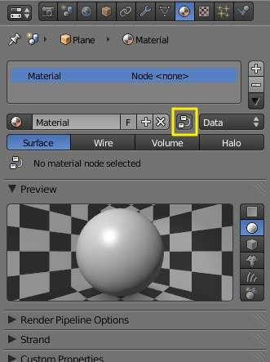  Material’s menu with Nodes enabled | 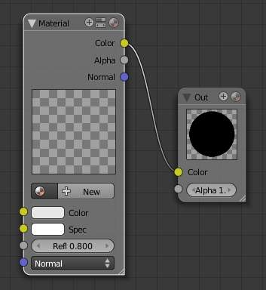  Default nodes
Let’s take the base material and hit the Nodes button next to the material name in the material panel or the node editor. You will see a change in the material panel.
What you have just done is told Bforartists to make the material you were on to become the node tree. Most of the panels we normally find in the material menu are now gone.
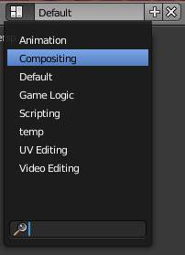
Accessing the Compositing screen
If you switch to the Compositing screen (Ctrl-Left if you are on the default screen) you’ll find a Node Editor on the top half of the screen. When you enabled material nodes, a material node and an output node were automatically added to the node editor.
You can also split the 3D view in the default screen in two and change one into a Node Editor.
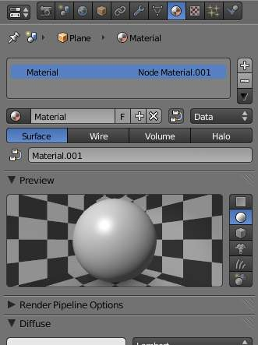  Material’s menu with a first material added to the Node Editor | 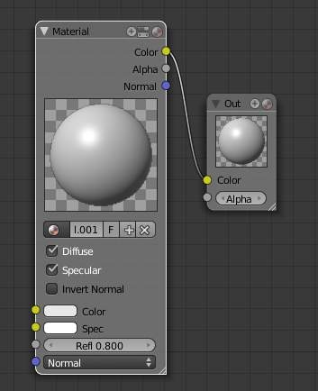  A first material added to the noodle
It is important to note that you can add a new material (which you can edit and change like any other material in the material panel), add an already created material or append a material from another Bforartists file, and also use the material that you used to create the node tree.
Here, we added a new material in the Node editor (Material.001), and as we did, we can access the properties of this material in the material’s menu.

Types of Material Nodes
This section is organized by type of node, which are grouped based on similar functions:
Input
Introduces a material or component to the node map.
Output
Displays the result in progress as a small image.
Color
Manipulates the colors of the material.
Vector
Change the way light is reflected off the material.
Convertors
Convert colors to other material colors.

Node Types

- Color Nodes
  - MixRGB
  - RGB Curves
  - Invert
  - Hue Saturation Value
- Convertor Nodes
  - ColorRamp Node
  - RGB to BW Node
  - Math Node
  - Vector Math Node
  - Squeeze Value Node
  - Separate RGB Node
  - Combine RGB Node
  - Separate HSV Node
  - Combine HSV Node
- Input Nodes
  - Material Node
  - Extended Material Node
  - Camera Data Node
  - Lamp Data Node
  - Value Node
  - RGB Node
  - Texture Node
  - Geometry Node
- Output Node
- Vector Nodes
  - Normal Node
  - Mapping Node
  - Vector Curves

Color Nodes

MixRGB
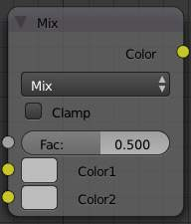
MixRGB node
This node mixes a base color or image (threaded to the top socket) together with a second color or image (bottom socket) by working on the individual and corresponding pixels in the two images or surfaces. The way the output image is produced is selected in the drop-down menu. The size (output resolution) of the image produced by the mix node is the size of the base image. The alpha and Z channels (for compositing nodes) are mixed as well.
Not one, not two, but count ‘em, sixteen mixing choices include:
See also
Color Blend Modes for details on each blending mode.

Inputs
Fac
The amount of mixing of the bottom socket is selected by the Factor input field (Fac:). A factor of zero does not use the bottom socket, whereas a value of 1.0 makes full use. In Mix mode, 0.5 is an even mix between the two, but in Add mode, 0.5 means that only half of the second socket’s influence will be applied.
Color 1
Input color value. The value can be provided by another node or set manually. Includes a color swatch, allowing you to select the color directly on the node.
Color 2
Input color value. The value can be provided by another node or set manually. Includes a color swatch, allowing you to select the color directly on the node.

Outputs
Color
Value of the color, combined by the node.

Controls
Clamp
Clamp result of the node to 0...1 range.

RGB Curves
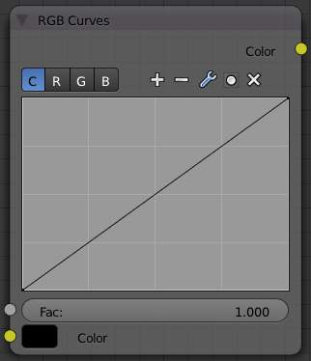
RGB Curves node
For each color component channel (RGB) or the composite (C), this node allows you to define a bezier curve that varies the input (x-axis) to produce an output value (y-axis). Clicking on one of the C R G B components displays the curve for that channel.
Note
- Read more about using the Curve Widget.
- RGB Curves node in the compositor (includes examples)

Invert
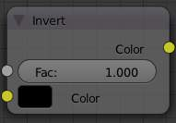
Invert node
This node simply inverts the input values and colors.

Inputs
Fac:
Factor. The degree of node’s influence in node tree. The value can be provided by another node or set manually.
Color
Input color value. The value can be provided by another node or set manually. Includes a color swatch, allowing you to select the color directly on the node.

Outputs
Color
Value of the color, combined by the node.

Hue Saturation Value
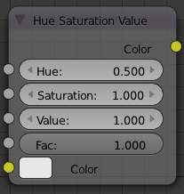
Hue Saturation Value node
Use this node to adjust the Hue, Saturation, and Value of an input.

Inputs
Fac
Factor. The degree of node’s influence in node tree. The value can be provided by another node or set manually.
Hue
Input hue value of color. The value can be provided by another node or set manually.
Saturation
Input saturation value of color. The value can be provided by another node or set manually.
Value
Input HSV-Value of color. The value can be provided by another node or set manually.
Fac
Factor. The degree of node’s influence in node tree. The value can be provided by another node or set manually.
Color
Input color value. The value can be provided by another node or set manually. Includes a color swatch, allowing you to select the color directly on the node.

Outputs
Color
Value of the color, combined by the node.

Convertor Nodes

As the name implies, these nodes convert the colors in the material in some way.

ColorRamp Node
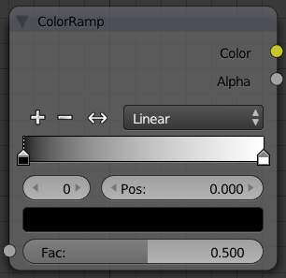
ColorRamp node
The ColorRamp Node is used for mapping values to colors with the use of a gradient. It works exactly the same way as a Colorband for textures and materials, using the Factor value as a slider or index to the color ramp shown, and outputting a color value and an alpha value from the output sockets.
By default, the ColorRamp is added to the node map with two colors at opposite ends of the spectrum. A completely black black is on the left (Black as shown in the swatch with an Alpha value of 1.00) and a whitewash white is on the right.
To select a color, LMB click on the thin vertical line/band within the colorband. The example picture shows the black color selected, as it is highlighted white. The settings for the color are shown above the colorband as (left to right): color swatch, Alpha setting, and interpolation type.

Inputs
Fac:
Factor. The degree of node’s influence in node tree. The value can be provided by another node or set manually.

Outputs
Color
Value of the color, combined by the node.
Alpha
Value of the alpha, combined by the node.

Controls
Add a new mark to the center of the colorband with the default color (neutral gray).
Remove the currently selected mark from the colorband.
Flip the colorband.
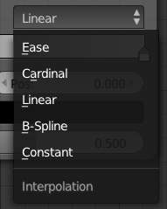
Modes of interpolation between marker’s values color ramp
Interpolation
Various modes of interpolation between marker’s values can be chosen in the Interpolation menu:
Ease
Ease by quadratic equation.
Cardinal
Cardinal.
Linear
Linear (default). A smooth, consistent transition between colors.
B-Spline
B-Spline.
Constant
Constant.
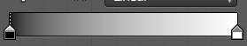
Colorband
Colorband
Contain a gradient through a sequence of many colors (with alpha), each color acting across a certain position in the spectrum.
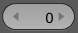
The number of the active mark.
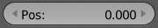
Pos. The position of the active color mark in the colorband (range 0.0–1.0). The position of the color marks can also be changed by LMB dragging them in the colorband.
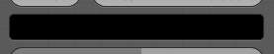
Color swatch to color selection for a mark
Color Selector
Allows set color and alpha values for each marker.
See more details about node controls’ functions here.

RGB to BW Node
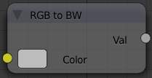
RGB to BW node
This node converts a color image to black-and-white.

Inputs
Color:
Input color value. Includes a color swatch, allowing you to select the color directly on the node.

Outputs
Value
Black-and-white value of the input color, converted by the node.

Math Node
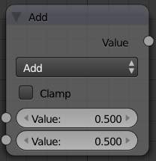
Math node
This node performs the selected math operation on an image or buffer. All common math functions are supported. If only an image is fed to one Value socket, the math function will apply the other Value consistently to every pixel in producing the output Value. Select the math function by clicking the up-down selector where the “Add” selection is shown.

Inputs
Value
Input value 1 (upper). The value can be provided by another node or set manually.
Value
Input value 2 (lower). The value can be provided by another node or set manually.

Outputs
Value
Output value, converted by the node.

Controls
Clamp
Clamps the result between 0 and 1.
Operation
Selector the math function for conversion.
Add
Add the two inputs
Subtract
Subtract input 2 from input 1
Multiply
Multiply the two inputs
Divide
Divide input 1 by input 2
Sine
The sine of input 1 (degrees)
Cosine
The cosine of input 1 (degrees)
Tangent
The tangent of input 1 (degrees)
Arcsine
The arcsine (inverse sine) of input 1 (degrees)
Arccosine
The arccosine (inverse cosine) of input 1 (degrees)
Arctangent
The arctangent (inverse tangent) of input 1 (degrees)
Power
Input 1 to the power of input 2 (input1^input2)
Logarithm
Log base input 2 of input 1
Minimum
The minimum of input 1 and input 2
Maximum
The maximum of input 1 and input 2
Round
Rounds input 1 to the nearest integer
Less Than
Test if input 1 is less than input 2, returns 1 for true, 0 for false
Greater Than
Test if input 1 is greater than input 2, returns 1 for true, 0 for false
Modulo
Division of input 1 by input 2 with remainder.
Absolute
Always return non-negative value from any operation input 2 between input 1.

Vector Math Node
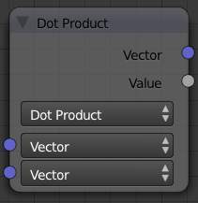
Vector Math node
This node performs the selected math operation on vectors. Select the math function by clicking the up-down selector where the “Add” selection is shown.

Inputs
Vector
Input vector 1 (upper). The value can be provided by another node or set manually.
Vector
Input vector 2 (lower). The value can be provided by another node or set manually.

Outputs
Vector
Output vector, converted by the node.
Value
Output value, converted by the node.

Controls
Operation
Selector the math function for conversion.
Add
Adding input 1 and 2.
Subtract
Subtracting input 1 and 2.
Average
Averaging input 1 and 2.
Dot Product
Algebraic operation that takes two equal-length sequences of vectors 1 and 2 and returns a single number. Result - scalar.
Cross Product
Geometric binary operation on two vectors 1 and 2 in three-dimensional space. It results in a vector which is perpendicular to both and therefore normal to the plane containing them. Result - vector.
Normalize
Normalizing input 1 and 2.

Squeeze Value Node
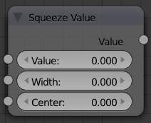
Squeeze Value node
This node is used primarily in conjunction with the Camera Data node used. The camera data generate large output values, both in terms of the depth information as well as the extent in the width. With the squeeze Node high output values to an acceptable material for the node degree, ie to values between 0.0 - 1.0 scaled down.

Inputs
Value
Any numeric value. The value can be provided by another node or set manually.
Width
Determines the curve between sharp S-shaped (width = 1) and stretched (Width = 0.1). Negative values reverse the course. The value can be provided by another node or set manually.
Center
The center of the output value range. This input value is replaced by the output value of 0.5. The value can be provided by another node or set manually.

Outputs
Value
A value between 0 and 1, converted by the node.

Separate RGB Node
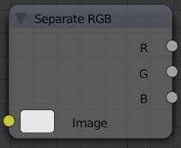
Separate RGB node
This node separates an image into its red, green and blue channels. The colors are then converted to intensity, which returns a greyscale to the output. For example, if you have an image with pure green, then the red and blue outputs will be black and the green output will be completely white. Mixed colors will return mixed values according to their RGB intensity.

Inputs
Image
Input color value. Includes a color swatch, allowing you to select the color directly on the node.

Outputs
R
Value of the red color channel, separated out by the node.
G
Value of the green color channel, separated out by the node.
B
Value of the blue color channel, separated out by the node.

Combine RGB Node
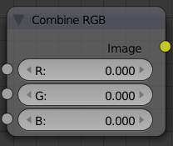
Combine RGB node
This node combines a color (image) from separated red, green, blue channels.

Inputs
R
Input value of red color channel. The value can be provided by another node or set manually.
G
Input value of green color channel. The value can be provided by another node or set manually.
B
Input value of blue color channel. The value can be provided by another node or set manually.

Outputs
Image
Output value of the color, combined by the node.

Separate HSV Node
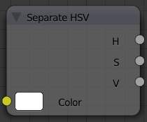
Separate HSV node
This node separates an image into image maps for the hue, saturation, value channels. Three values, often considered as more intuitive than the RGB system (nearly only used on computers)
Use and manipulate the separated channels for different purposes; i.e. to achieve some compositing/color adjustment result. For example, you could expand the Value channel (by using the multiply node) to make all the colors brighter. You could make an image more relaxed by diminishing (via the divide or map value node) the Saturation channel. You could isolate a specific range of colors (by clipping the Hue channel via the Colorramp node) and change their color (by the Add/Subtract mix node).

Inputs
Color
Input color value. Includes a color swatch, allowing you to select the color directly on the node.

Outputs
H
Value of the hue color channel, separated out by the node (choose a color of the rainbow).
S
Value of the saturation color channel, separated out by the node (the quantity of hue in the color (from desaturate - shade of gray - to saturate - brighter colors)).
V
Value of the value color channel, separated out by the node (the luminosity of the color (from ‘no light’ - black - to ‘full light’ - ‘full’ color, or white if Saturation is 0.0)).

Combine HSV Node
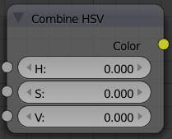
Combine HSV node
This node combines a color from separated hue, saturation, value color channels.

Inputs
H
Input value of hue color channel. The value can be provided by another node or set manually.
S
Input value of saturation color channel. The value can be provided by another node or set manually.
V
Input value of value color channel. The value can be provided by another node or set manually.

Outputs
Color
Output value of the color, combined by the node.

Input Nodes

A starting material is created in the Materials Panel. The Nodes button is enabled to add that material to the list of noded materials shown in the Node Editor window header. Other inputs to the node map include:
- A value
- A color
- A texture
- Geometry
- Material
- Camera Data
- Lamp Data

Material Node
Reference
Panel: Node Editor –> Material Nodes
Menu: Input –> Material

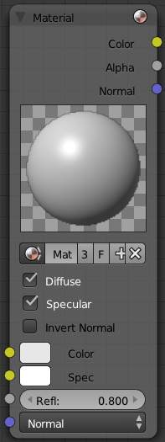
Material node
The Material node is used to add a material to the node program. Materials can be anything from pure shading to fully layered with textures. It inputs the main attributes of a material (color, alpha and normal vector) into the map.

Output
Materials can output color (which includes shading and any textures assigned to it), alpha, and the final normal calculated from any textures it has.
Color
value of the color, combined by the node.
Alpha
value of the alpha, combined by the node.
Normal
direction of the normal, combined by the node.

Input
Materials can take inputs for colors, inputs for diffuse color and specularity color, a value for reflectivity, and a normal.
Color
The base color of the paint. Can be set
- manually by LMB clicking on the color swatch applet next to the socket, choosing a color using the control panel that pops up, and pressing Return
- based on an Active Material which is specified using the material panels, or
- plugged in from an RGB color generator.
Spec
The color that is reflected as you get perpendicular to the light source reflecting off the surface. The color can be
- plugged in from another node or...
- set manually by LMB clicking on and using the color swatch applet.
Refl:
The degree to which the material reflects light and gives off its color. The value can be provided by another node or set manually.
Normal
The lighting condition.

Controls
Material field
You can browse and select materials here.
Diffuse toggle
Turn on/off Diffuse Color.
Specular toggle
Turns on/off Specularity calculation.
Invert Normal toggle
Inverts the material input normal when activated (which, of course, is a combination of the 3D normal given to it by the 3D object plus the normal input point).
Note
Normal Override
The normal input socket does not in any way blend the source normal with the underlying geometry. Any plugged in Geometry here overrides the Normal lighting conditions.

Using the Material Node with Specularity
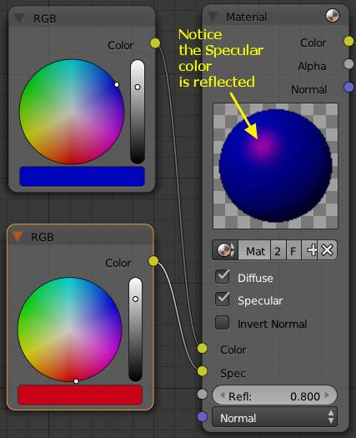
Material Node using Specularity
To make a material node actually generate a color, you have to specify at least a basic input color, and optionally a specularity color. The specularity color is the color that shines under intense light.
For example, consider the mini-map to the right. The base color, a dark blue, is connected from an RGB color generator node to the Color input socket. The specular color, yellow, is connected to the Spec input. Under Normal lighting conditions on a flat surface, this material will produce a deep blue color and, as you approach a spot perpendicular to the light, you will see the yellow specular color mix in.

Note
Enable Spec
To see specularity, you have to enable it by clicking the blue Spec button located just below the material color swatch in the node.

Extended Material Node
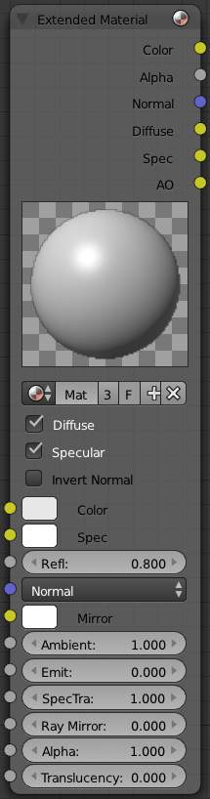
Extended Material node
Adds additional input and output channels to the material node.

Input
Color
Includes a color swatch, allowing you to select the color directly on the node.
Mirror Color
Color of mirrored reflection.
Ambient
Amount of global ambient color the material receives.
Emit
Amount of light to emit.
SpecTra
Alpha for the specular color.
Ray Mirror
Amount of reflectiveness of the object.
Alpha
Transparency of the material by setting all pixels in the alpha channel to the given value.
Translucency
Amount of diffuse shading on the back side

Output
Materials can additionaly output the followings:
Diffuse
value of the diffuse color, combined by the node.
Spec
value of the specular color, combined by the node.
AO
value of the Ambient Occlusion, combined by the node.

Camera Data Node
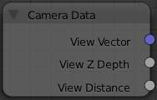
Camera Data node
View Vector
A Camera space vector from the camera to the shading point.
View Z Depth
How far away each pixel is from the camera
View Distance
Distance from the camera to the shading point.

Lamp Data Node
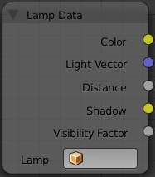
Lamp Data node
The Lamp Data node is used to obtain information related to a specified lamp object. Select a lamp object listed in the Lamp field, then the following outputs will be available:
Color
Lamp color multiplied by the lamp energy.
Light Vector
An unit vector in the direction from the shading point to the lamp.
Distance
Distance from the shading point to the lamp.
Shadow
Shadow color that the other objects cast on the shading point.
Visibility Factor
Light falloff ratio at the shading point.
The light textures and the shadow textures affect the Color and Shadow outputs, respectively.
Note
Portability to Various Scenes
If multiple materials use a Lamp Data node linking to the same lamp object, including the Lamp Data node into a node group is recommended. Otherwise, when the mesh objects are imported to the other scene, all the materials may need to be modified.

Value Node
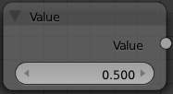
Value node
The Value node has no inputs; it just outputs a numerical value (floating point spanning 0.00 to 1.00) currently entered in the NumButton displayed in its controls selection.
Use this node to supply a constant, fixed value to other nodes’ value or factor input sockets.

RGB Node
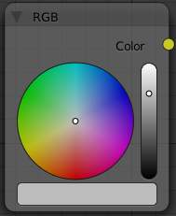
RGB node
The RGB node has no inputs. It just outputs the value Color currently selected in its controls section.

Texture Node
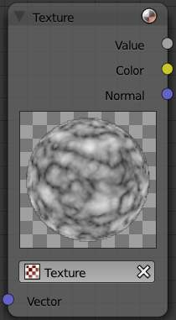
Texture node
A texture, from the list of textures available in the current blend file, is selected and introduced through the value and/or color socket.
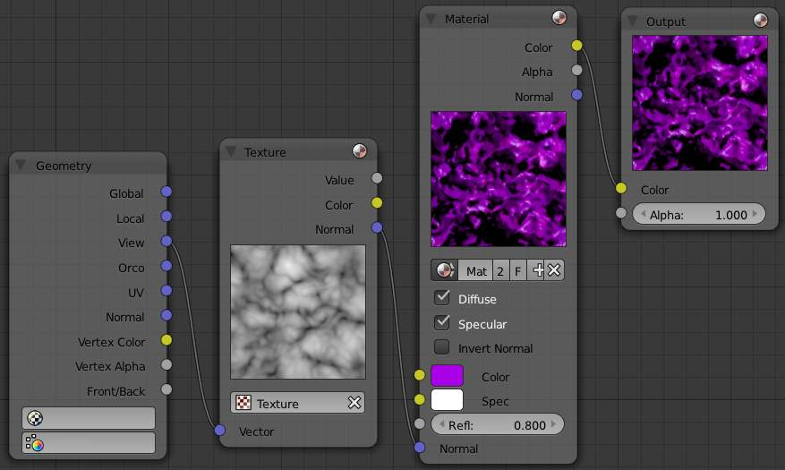
Example of the applying Texture node

Input
Vector
Uses for map the texture to a specific geometric space.

Outputs
Value
Straight black-and-white value of the texture, combined by the node.
Color
Texture color output, combined by the node.
Normal
Direction of normal texture, combined by the node.
In the example to the right, a cloud texture, as it would appear to a viewer, is added to a base purple material, giving a velvet effect.
Note that you can have multiple texture input nodes. With nodes, you simply add the textures to the map and plug them into the map.

Geometry Node
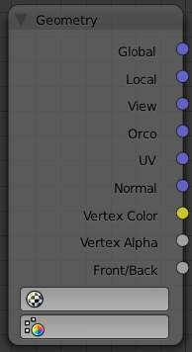
Geometry node
The geometry node is used to specify how light reflects off the surface. This node is used to change a material’s Normal response to lighting conditions.
Use this node to feed the Normal vector input on the Material node, to see how the material will look (i.e. shine, or reflect light) under different lighting conditions. Your choices are:
Global
Global position of the surface.
Local
Local position of the surface.
View
Viewed position of the surface.
Orco
Using the Original Coordinates of the mesh.
UV
Using the UV coordinates of the mesh, selected in the field in bottom node.
Normal
Surface Normal; On a flat plane with one light above and to the right reflecting off the surface.
Vertex Color
Allows for output value of group vertex colors, selected in the field in bottom node.
Vertex Alpha
Allows for output alpha value of vertex.
Front/Back
Allows for output to take into account front or back of surface is light relative the camera.
Note
These are exactly the same settings as in the Mapping panel for Textures, though a few settings - like Stress or Tangent - are missing here. Normally you would use this node as input for a Texture Node.

Geometry Node Example using a UV image
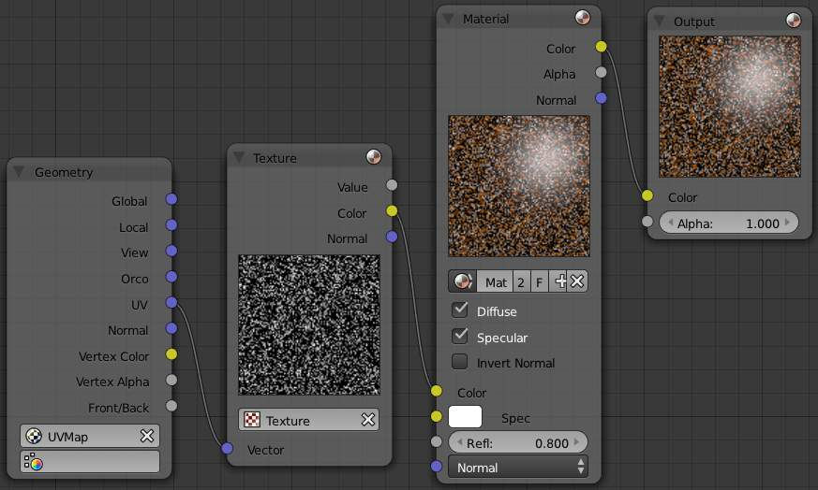
Setup to render an UV-Mapped Image Texture.
E.g.: To render an UV-mapped image, you would use the UV output and plug it into the Vector Input of a texture node. Then you plug the color output of the texture node into the color input of the material node - which corresponds to the setting on the Map To panel.

Output Node

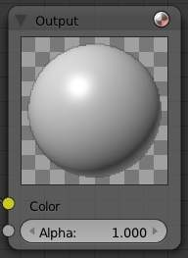
Output material node
At any point, you may want to see the work in progress, especially right after some operation by a node. Simply create another thread from the output socket of the node to the picture input socket of an Output node to see a mini-picture.
Connect the alpha channel to set/see transparency.
Note
Effective Output Node
The only Output node that is used for the Material in the end (i.e the only non-Preview) has a little red sphere on the upper right.

Vector Nodes

Vector nodes manipulate information about how light interacts with the material, multiplying vector sets, and other wonderful things which can become quite advanced. Even if you don’t have experience with vector maths, you’ll find these nodes to be very useful.
Vectors, in general, are two or three element values, for example, surface normals are vectors. Vectors are also important for calculating shading.

Normal Node
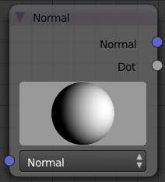
Normal node
The Normal node generates a normal vector and a dot product. Click and Drag on the sphere to set the direction of the normal.
This node can be used to input a new normal vector into the mix. For example, use this node as an input to a Color Mix node. Use an Image input as the other input to the Mixer. The resulting colorized output can be easily varied by moving the light source (click and dragging the sphere).
The (face) normal is the direction of the face in relation to the camera. You can use it to do the following:
- Use this node to create a fixed direction –> output Normal.
- Calcuate the Dot -Product with the Normal -Input. The Dot -Product is a scalar value (a number).
  - If two normals are pointing in the same direction the Dot -Product is 1.
  - If they are perpendicular the Dot -Product is zero (0).
  - If they are antiparallel (facing directly away from each other) the Dot -Product is -1. And you never thought you would use the Vector Calculus class you took in college - shame on you!
So now we can do all sorts of things that depends on the viewing angle (like electron scanning microscope effect). And the best thing about it is that you can manipulate the direction interactively.
Note
One caveat
The normal is evaluated per face, not per pixel. So you need enough faces, or else you don’t get a smooth result

Inputs
Normal
3D-direction of the face in relation to the camera. The value can be provided by another node or set manually.

Outputs
Normal
Fixed 3D-direction, combined by the node.
Dot
Scalar value (a number), combined by the node.

Controls
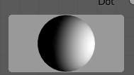
Interactive Normal node preview
Interactive node preview
Allows click and drag on the sphere in node center to set the direction of the normal.

Mapping Node
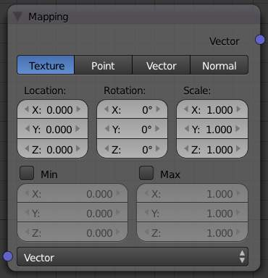
Mapping node
Essentially mapping node allows the user to modify a mapping of system of 3D-coordinates. Typically used for modifying texture coordinates.
Mapping can be rotated and clamped if desired.

Inputs
Vector
The input vector (3D-direction in relation to the camera) of some the coordinates’ mapping. The value can be provided by another node or set manually.

Outputs
Vector
The output vector, combined by the node.

Controls
The controls of the node have been ordered in X, Y, Z order. If you want to use the clamping options, try enabling Min and Max.
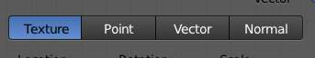
Mapping Node Vector Types controls
Vector type selector
Type of vector that the mapping transforms.
Texture
Transform a texture by inverse mapping the texture coordinates.
Point
Transform a point.
Vector
Transform a direction vector.
Normal
Transform a normal vector with unit length.
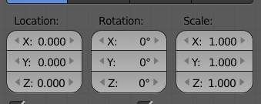
Mapping Node Transforms controls
Location
Transform position vector.
Rotation
Transform rotation vector.
Scale
Transform scale vector.
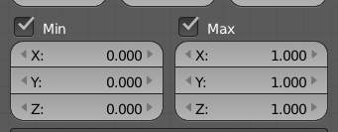
Mapping Node Clipping controls
Min
Minimum clipping value.
Max
Maximum clipping value.

Vector Curves
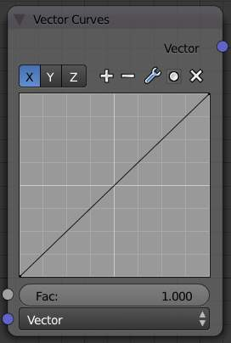
Vector Curves node
The Vector Curves node maps an input vector X, Y, and Z components to a diagonal curve. Use this node to remap a vector value using curve controls.
See also
- Read more about using the Curve Widget.

Inputs
Fac:
Factor. The degree of node’s influence in node tree. The value can be provided by another node or set manually.
Vector
The input vector (3D-direction in relation to the camera). The value can be provided by another node or set manually.

Outputs
Vector
The output vector, combined by the node.

Options

Materials
Materials can be linked to objects and Object’s data in the materials panel, of the Shading/Material context. Here is where you can manage how materials are linked to objects, meshes, etc. and activate a material for editing in the rest of the panels.

Context
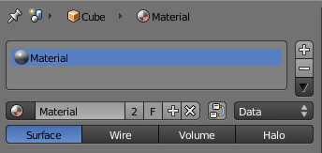
Material panel
At the top of the material menu a list of icons explains the context in which the material is being edited. In the example above, the material Material is linked to the object Cube which is linked to the scene Scene.
By toggling the pin symbol on the left side on and off, Bforartists can be told to display only the selected material or to follow context.

Material slots
With a material linked or created, one or several material slots can be created and further options become available:
Plus sign
Add a new material slot or copy the one selected
Minus sign
Remove selected material slot
Down arrow
Copy and paste the selected material slot

Multiple materials
Meshes can handle having more than one material. Materials can be mapped on a per-face basis, as detailed on the Multiple Materials page. In edit mode, the following tools appear:
Assign
Assign the material in the selected material slot to selected vertices
Select
Select vertices assigned to the selected material slot
Deselect
Deselect vertices assigned to the selected material slot

Material naming and linking
Link material to object or to object’s data
Material’s name field
click into this field to rename your material
Number of users (number field)
The number of objects or object’s data that use the material. This material is linked between the various objects, and will update across all of them when edited. Clicking this number will make a ‘single user copy’, duplicating the material, with it linked only to the active object/object’s data.
F (Fake user)
Gives the material a ‘fake user’, to keep the material data-block saved in the .blend file, even if it has no real users.
Plus sign
Add a new material.
X sign
Remove link to this material.
Nodes
Designates this material to be a material node noodle, and not from the Material/Ramps/Shaders settings.
Data-block links
The Link pop-up menu has two choices, Data and Object. These two menu choices determine whether the material is linked to the object or to the data, (in this case, the mesh). The Data menu item determines that this material will be linked to the mesh’s data-block which is linked to the object’s data-block. The Object menu item determines that the material will be linked to the object’s data block directly.
This has consequences of course. For example, different objects may share the same mesh data-block. Since this data-block defines the shape of the object any change in edit mode will be reflected on all of those objects. Moreover, anything linked to that mesh data-block will be shared by every object that shares that mesh. So, if the material is linked to the mesh, every object will share it.
On the other hand, if the material is linked directly to the object data-block, the objects can have different materials and still share the same mesh.
Short explanation: If connected to the object, you can have several instances of the same obData using different materials. If linked to mesh data, you can’t.

Material type
Material added in edit mode These toggles tell Bforartists where this material fits into the Render Pipeline, and what aspects of the material are to be rendered.
Surface
Render object as a surface
Wire
Render the edges of faces as wires (not supported in ray tracing)
Volume
Render object as a volume. See Volume Material
Halo
Render object as halo particles. See Halo Material

Material Properties Overview
The usage of each section of the material properties are detailed in the next section.

Surface and Wire materials
Surface material types are the most common materials. They represent objects with a defined surface.
Wire materials simply turn all of an object’s edges into rods, which then become renderable, but uses the same shading options as surface materials.

Preview
This is a preview of the current material mapped on to one of several objects.
- Flat Plane
- Sphere
- Cube
- Monkey
- Strands
- Large Sphere with Sky
See Preview

Diffuse
Diffuse shading simulates light hitting a surface and bouncing off in a very wide angle. You can set the color of the diffuse shading, and set what model is used for the diffuse calculation.
See Diffuse Shaders

Specular
Specularity simulates reflections of light sources, that are often sharp, bright spots. You can set the color of the specular shading, and set what model is used for the specular calculation.
See Specular Shaders

Shading
Emit
Adds extra illumination, as if the material is glowing.
Ambient
Sets the global amibient light the material receives
Translucency
Amount of shading on the back side that shows through. Use to simulate thin objects, like leaves or paper.
Shadeless
This disables the calculation of any shading, so only color information is visible. This is essentially makes it a “surface shader”
Tangent Shading
Use the material’s tangent vector instead of the normal for shading - for anisotropic shading effects (e.g. soft hair and brushed metal). This shading was introduced in 2.42, see also settings for strand rendering in the menu further down and in the Particle System menu.
Cubic Interpolation
Use cubic interpolation for diffuse values, for smoother transitions between light areas and dark areas

Transparency
Set options for objects in which light can pass through
See Transparency

Mirror
Here you can set options for materials that are reflective
See Mirror

Subsurface Scattering
Subsurface scattering simulates semi translucent objects in which light enters, bounces around, then exits in a different place. Examples are candles, human skin, cheese, etc.
See Subsurface Scattering

Strand
These settings are used when rendering the material on fur or hair
See Strands

Options
Traceable
Allows material to calculated raytracing, for reflections and refractions.
Full Oversampling
Forces material to render full shading and textures for all Anti-Aliasing Samples.
Sky
Renders material with no alpha, replacing the background with the sky
Use Mist
Uses Mist with this material.
Invert Z Depth
Renders materials faces with an inverted Z buffer.
Z Offset
If using Invert Z Depth, this is an artificial offset to z values.
Light Group
Limit material’s lighting calculation to a specific light group
Exclusive
Material uses light group exclusively
Face Textures
Replaces object’s base color with color from face assigned image textures.
Face Textures Alpha
Replaces object’s base alpha value with alpha from face assigned image textures.
Vertex Color Paint
Replaces object’s base color with vertex colors.
Vertex Color Light
Adds vertex color as additional light.
Object Color
Modulate the result with a per object color.

Shadow
Receive
Allows the material to receive shadows cast by other objects
Receive Transparent
Allows material to receive transparent shadows cast by other transparent objects.
Cast Only
Causes objects with the material to only cast a shadow, and not appear in renders.
Casting Alpha
Sets the Alpha of shadow casting. Used for irregular and deep shadow buffering.
Shadows Only
Renders shadows as materials alpha value, making materials transparent, except for shadowed areas.
Shadow Only Type
Set the type of shadows used when Shadows Only is enabled
- Shadow and Distance
- Shadow Only
- Shadows and Shading
Cast Buffer Shadow
Allows material to cast shadows from buffer lamps.
Buffer Bias
Factor to multiply shadow buffer by.
Auto Ray Bias
Prevents raytraced shadow errors on surfaces with smooth normals
Ray Bias
Shadow raytracing bias value to prevent terminator artifacts on shadow boudary.
Cast Approximate
Allow material to cast shadows when using Approximate Ambient Occlusion}}

Volume Material
Volume materials represent volumes of tiny particles, like clouds or smoke. They are very different from standard materials, but are detailed in the Volume Page.

Halo Material
Halo materials renders each of the objects points as glowing dots. This is a useful material for simulating particle effects or lens flares. They are detailed on the Halo Page.

Special Material Effects

- Halo Rendering
  - Options
  - Halo Texturing
  - Examples
- Volume Rendering
  - Options
- Wire Render

Halo Rendering

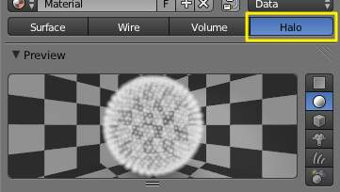
Activating helo rendering
Bforartists provides a set of materials which do not obey the face-shader paradigm and which are applied on a per-vertex rather than on a per-face basis. These are called Halos because you can see them, but they do not have any substance. They are like little clouds of light; although they are not really lights because they do not cast light into the scene like a lamp.
Halos come in very handy when creating certain special effects, when making an object glow, or when creating a viewable light or fog/atmospherics around an actual light.

Options
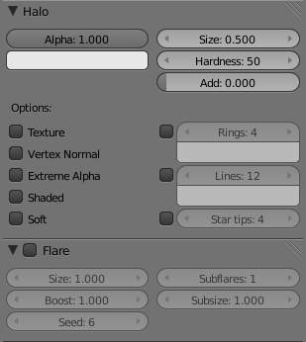
Halo panels
To enable Halos, press the Halo button in the Material menu’s top panel.
As you will see in the 3D View, the mesh faces are no longer rendered. Instead just the vertex is rendered, since that is where each halo will originate. Halos can be hard to find in a crowded scene, so name it well for easy location in the outliner.
In the properties window, where we normally find the Diffuse, Specular, and Shading panels, we now see panels relative to the Halo characteristics:

Halo Panel
Alpha
The transparency
Color Swatch
The color of the halo itself
Seed
If non-zero, randomizes the ring dimension and line location. To use, give any (integer) number to start the random-number generator.
Size
Sets the dimension of the halo
Hardness
Sets the hardness of the halo. Similar to specular hardness
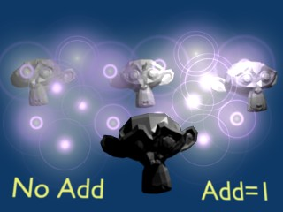
Effect of Add
Add
The Add slider determine how much the halo colors are ‘added to’, rather than mixed with, the colors of the objects behind and together with other halos. By increasing Add, the Halo will appear to light up objects that move behind it or through the Halo field.
Texture
Gives halo a texture. By default, textures are applied to objects with Object coordinates and reflects on the halos by affecting their color, as a whole, on the basis of the color of the vertex originating the halo. Enable this feature to have the texture take effect within the halo, and hence to have it with varying colors or transparencies; this will map the whole texture to every halo. This technique proves very useful when you want to create a realistic rain effect using particle systems, or similar.
Vertex Normal
Use the vertex normal to specify the dimension of the halo
Extreme Alpha
Boosts alpha
Shaded
Lets halo receive light and shadows from external objects
When shaded is enabled, the Halo will be affected by local light; a lamp will make it brighter and affect its diffuse color and intensity.
Soft
Softens the edges of the halos at intersections with other geometry
In addition, several other special effects are available. To enable some or all of these effects, set the number of points/rings, or set the color of each effect individually:
Rings
Adds circular rings around to the halo.
Lines
Adds lines from the center of the halo.
Star tips
Gives the halo a star shape.
You can not use color ramps. Lines, Rings and an assortment of special effects are available with the relevant toggle buttons, which include Flare, Rings, Lines, Star, Texture, Extreme Alpha, and Shaded. Halo Variations shows the result of applying a halo material to a single vertex mesh.
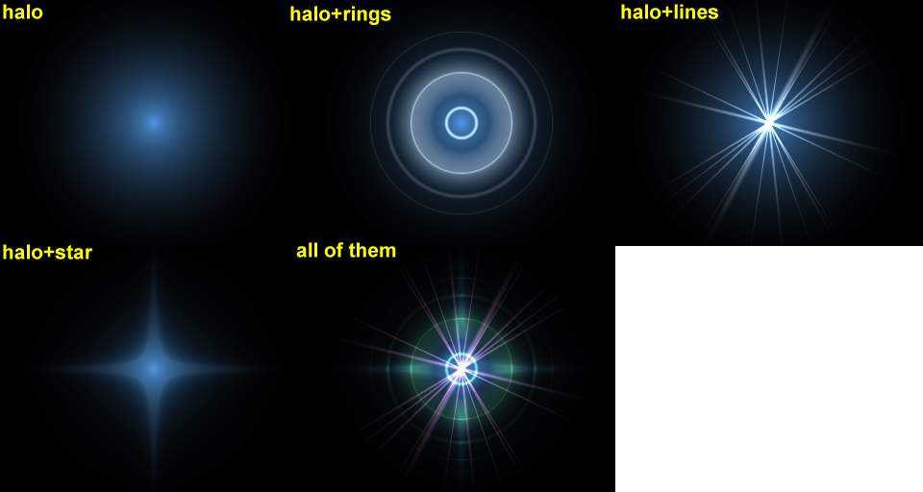
Halo Variations
The halo size, hardness and alpha can be adjusted with the pertinent sliders. These are very similar to traditional material settings
The Add slider determine how much the halo colors are ‘added to’, rather than mixed with, the colors of the objects behind and together with other halos. By increasing Add, the Halo will appear to light up objects that move behind it or through the Halo field.
To set the number of rings, lines, and star points independently, once they are enabled with the relative Toggle Button, use the Num Buttons Rings:, Lines: and Star:. Rings and lines are randomly placed and oriented, to change their pattern you can change the Seed: Num Button which sets the random numbers generator seed.

Flare Panel
Enabling Flare Renders the halo as a lens flare
Size
Sets the factor by which the flare is larger than the halo
Boost
Give the flare extra strength.
Seed
Specifies an offset in the flare seed table
Subflares
Sets the number of subflares
Subsize
Sets the dimensions of the subflares, dots, and circles

Lens Flares
Our eyes have been trained to believe that an image is real if it shows artifacts that result from the mechanical process of photography. Motion blur, Depth of Field, and lens flares are just three examples of these artifacts. The first two are discussed in the chapter_rendering; the latter can be produced with special halos. A simulated lens flare tells the viewer that the image was created with a camera, which makes the viewer think that it is authentic.
We create lens flares in Bforartists from a mesh object using first the Halo button and then the Flare options in the Shaders Panel of the material settings. Try turning on Rings and Lines, but keep the colors for these settings fairly subtle. Play with the Flares: number and Fl. seed: settings until you arrive at something that is pleasing to the eye. You might need to play with Boost: for a stronger effect (Lens Flare settings).
Note that this tool does not simulate the physics of photons traveling through a glass lens; it’s just a eye candy.
Bforartists’s lens flare looks nice in motion, and disappears when another object occludes the flare mesh.
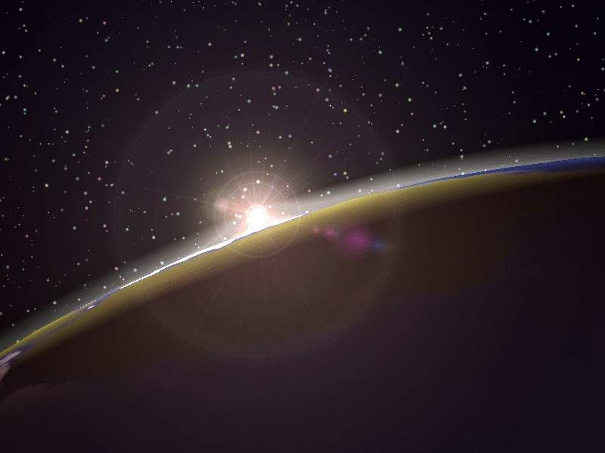
Lens Flare

Halo Texturing
By default, textures are applied to objects with Object coordinates and reflects on the halos by affecting their color, as a whole, on the basis of the color of the vertex originating the halo. To have the texture take effect within the halo, and hence to have it with varying colors or transparencies press the Texture button; this will map the whole texture to every halo. This technique proves very useful when you want to create a realistic rain effect using particle systems, or similar.
Another Option is Shaded. When shaded is enabled, the Halo will be affect by local light; a lamp will make it brighter and affect its diffuse color and intensity.

Examples

Dotmatrix display
Let’s use a halo material to create a dotmatrix display.
- To begin, add a grid with the dimensions 32x16. Then add a camera and adjust your scene so that you have a nice view of the billboard.
- Use a 2D image program to create some red text on a black background, using a simple and bold font (if you are a lazy lizard [I hope this not offensive, I just like how it sounds!], you can just save the picture below on your hard drive...). Dot matrix image texture. shows an image 512 pixels wide by 64 pixels high, with some black space at both sides.

Dot matrix image texture.
- Add a material for the billboard, and set it to the type Halo. Set the HaloSize to 0.06 and when you render the scene you should see a grid of white spots.
- Add a Texture, then change to the Texture Buttons and make it an image texture. When you load your picture and render again you should see some red tinted dots in the grid.
- Return to the Material Buttons and adjust the sizeX parameter to about 0.5 then render again; the text should now be centered on the Billboard.
- To remove the white dots, adjust the material color to a dark red and render. You should now have only red dots, but the billboard is still too dark. To fix this enter EditMode for the board and copy all vertices using the Shift-D shortcut (take care not to move them!). Then adjust the brightness with the Add value in the MaterialButtons.
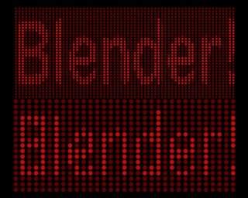
Dot Matrix display.
You can now animate the texture to move over the billboard, using the ofsX value in the Texture panel of the MaterialButtons. (You could use a higher resolution for the grid, but if you do you will have to adjust the size of the halos by shrinking them, or they will overlap. (Dot Matrix display).
Note
Note about material indices
Halo materials only work when applied using the first material index. Any material(s) in a subsequent material index will not be rendered.

Volume Rendering

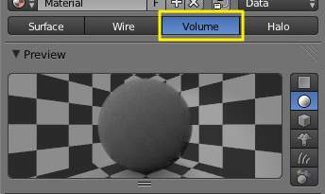
Activation volume rendering
Volume rendering is a method for rendering light as it passes through participating media, within a 3d region. The implementation in Bforartists a physically based model, which represents the various interactions of light in a volume relatively realistically.
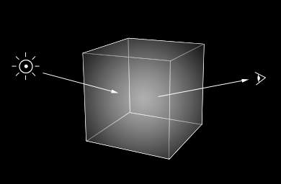
Volume rendering
Rendering a volume is different then Solid Render. For volume light enters a 3D region of space (defined as the volume) that may be filled with small particles, such as smoke, mist or clouds. The light bounces around off the various molecules, being scattered or absorbed, until some light passes through the volume and reaches the camera. In order for that volume to be visible, the renderer must figure out how much material the light has passed through and how it has acted and reacted within that volume, the volume object needs to contain a 3D region of space, for example a manifold closed mesh, such as a cube, not just a flat surface like a plane. To get an image, the renderer has to step through that region, and see how much ‘stuff’ is there (density) in order to see how light is absorbed or scattered or whatever. This can be a time consuming process since it has to check a lot of points in space and evaluate the density at each.

Options

Density
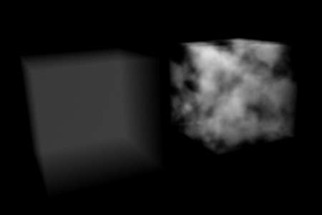
Constant density vs textured density
Many things can happen to the light as it passes through the volume, which will influence the final color that arrives at the camera. These represent physical interactions that happen in the real world, and most of these are dependent on the density of the volume, which can either be a constant density throughout, or varied, controlled by a texture. It is by controlling the density that one can get the typical ‘volumetric’ effects such as clouds or thick smoke.
Density
The base density of the material - other density from textures is added on top
Density Scale
A global multiplier to increase or decrease the apparent density. This can be useful for getting consistent results across different scene scales.

Shading
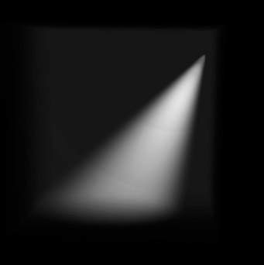
Spot lamp scattering in a constant volume
When light enters a volume from an external source, it doesn’t just pass straight through. Light gets scattered off tiny particles in the volume, and some proportion of that light reaches the camera. This property makes it possible to see light beams as they travel though a volume and are scattered towards the eye.
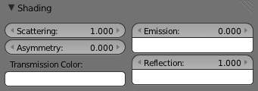
Shading options
Scattering
The amount of light that is scattered out of the volume. The more light that is scattered out of the volume, the less it will penetrate through the rest of the volume. Raising this parameter can have the effect of making the volume seem denser, as the light is scattered out quickly at the ‘surface’ of the volume, leaving the areas internal to the volume darker, as the light doesn’t reach it.
Note in the examples below, the less light that is scattered out of the volume, the more easily it penetrates throughout the volume and to the shadow.
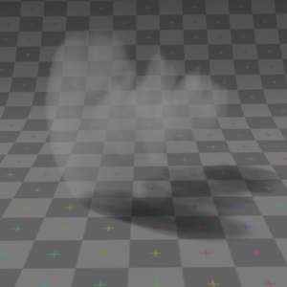  Scattering: 0.5 | 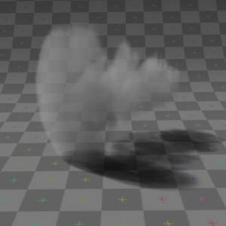  Scattering: 1.0 | 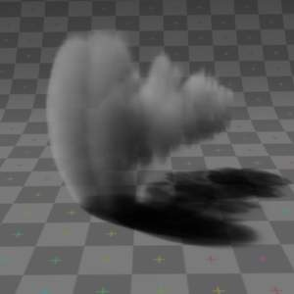  Scattering: 2.0 | 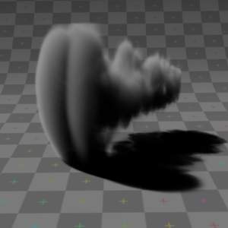  Scattering: 5.0

Asymmetry
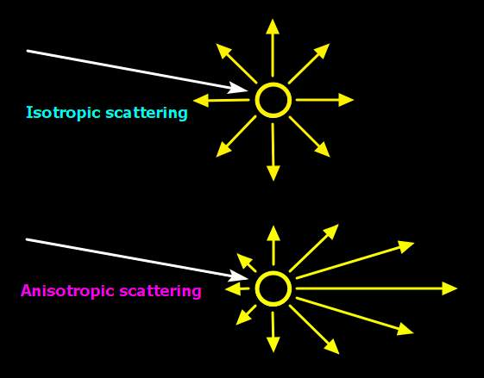
Isotropic and Anisotropic scattering
The default method for scattering light in a volume is for the light to be deflected evenly in all directions - known as Isotropic scattering. In real life different types of media can scatter light in different angular directions, known as Anisotropic scattering. Back-scattering means that light is scattered more towards the incoming light direction, and forward-scattering means it’s scattered along the same direction as the light is traveling.
Asymmetry
Asymmetry controls the range between back-scattering (-1.0) and forward-scattering (1.0). The default value of 0.0 gives Isotropic scattering (even in all directions).

Transmission
Transmission is a general term for light that is transmitted throughout a volume.
This transmitted light can be the result of various different interactions, for example:
- the left over result of incoming light after it has reflected/scattered out of the volume
- the left over result of light after being absorbed by the volume (and converted to heat)
Here, the transmission color is used to set the end result color that light becomes after it is transmitted through the volume.
Transmission Color
The resultant color of light that is transmitted through the volume.
Note in the examples below, as more light is scattered out of the volume, there is less available to be transmitted through.
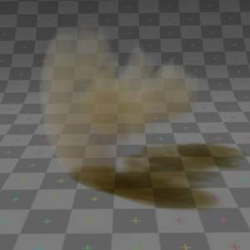  Transmission color: Yellow, Scattering: 0.5 | 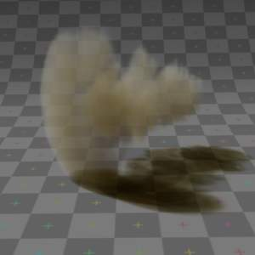  Transmission color: Yellow, Scattering: 1.0 | 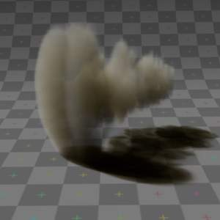  Transmission color: Yellow, Scattering: 2.0 | 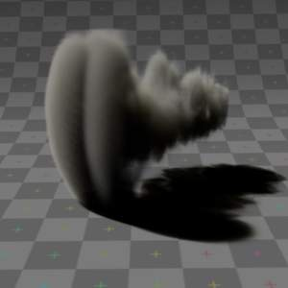  Transmission color: Yellow, Scattering: 5.0

Emission
Some volumes can emit light where there was none before, via chemical or thermal processes, such as fire. This light is generated from the volume itself and is independent of light coming from external sources.
Currently, this emitted light does not affect other volumes or surfaces (similar to surface material type, ‘Emit’ option).
Emission Color
The color of light that is emitted by the volume.
Emission
An intensity multiplier for the emitted color, for scaling up and down.
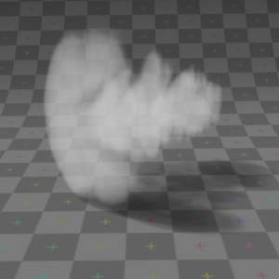  Emission 0.25, Scattering: 0.5 | 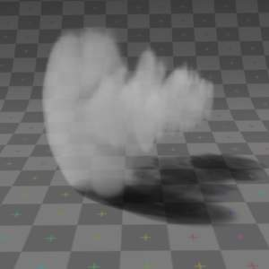  Emission 0.25, Scattering: 1.0 | 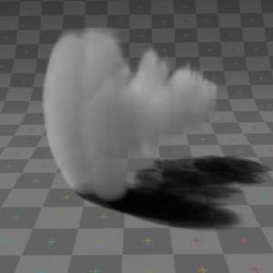  Emission 0.25, Scattering: 2.0 | 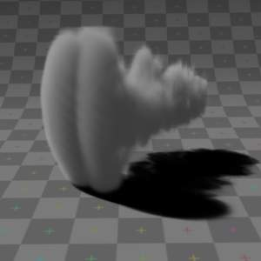  Emission 0.25, Scattering: 5.0

Reflection
The ‘reflection’ parameters can be used to tint or scale the light that’s scattered out of the volume. This only affects light that has come from lamps and been scattered out, it doesn’t affect the color of transmitted or emitted light and is.
These settings are not physically correct because they don’t conserve energy - the light scattering out doesn’t affect the remaining light that is transmitted throughout the rest of the volume. For example, physically speaking, if the orange components of the light are scattered out of the volume towards the camera, only the inverse of that (blue) will remain to continue penetrating through the volume, causing the volume to take on a multi-colored appearance, which can be difficult to use. To make it a bit easier to plainly set the color of the volume, you can use the reflection parameters to quickly set an overall tint.
Reflection Color
The color of light that is scattered out of the volume.
Reflection
An intensity multiplier for the reflection, for scaling up and down.

Hints
Ideally try to accomplish as much as you can with the other volume settings and lighting before using the reflection controls. If you stick to what’s physically plausible, the material will act correctly, and be more predictable and usable in a wider range of lighting scenarios. Of course you can always break the rules too!
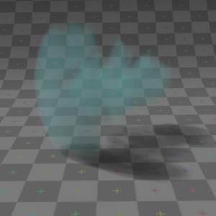  Reflection: Green, Scattering: 0.5 | 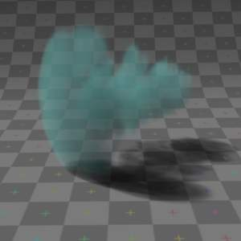  Reflection: Green, Scattering: 1.0 | 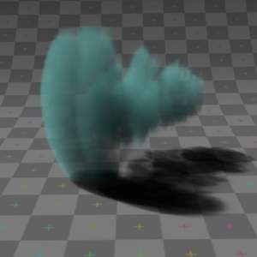  Reflection: Green, Scattering: 2.0 | 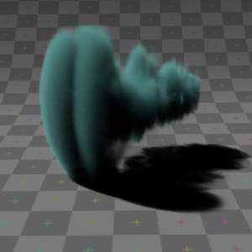  Reflection: Green, Scattering: 5.0
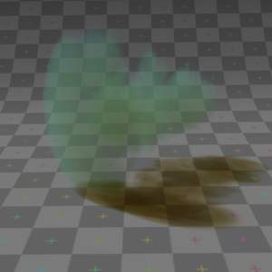  Reflection: Green, Transmission: Yellow, Scattering: 0.5 | 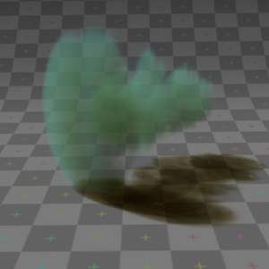  Reflection: Green, Transmission: Yellow, Scattering: 1.0 | 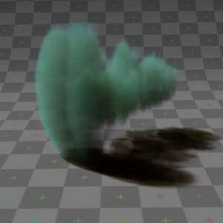  Reflection: Green, Transmission: Yellow, Scattering: 2.0 | 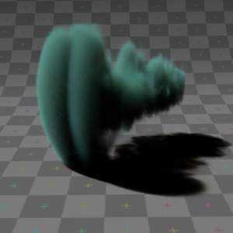  Reflection: Green, Transmission: Yellow, Scattering: 5.0

Lighting
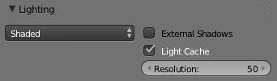
Lighting options
Several shading modes are available, providing a range of options between fast to render and physically accurate.
Lighting Mode
Shadeless
Shadeless is the simplest, useful for thin, wispy mist or steam.
Shadowed
Shadowed is similar, but with shadows of external objects.
Shaded
Shaded uses a volumetric single-scattering method, for self-shading the volume as light penetrates through.
Multiple Scattering
Allows multiple scatter calculations.
Shaded+Multiple Scattering
Combines Shaded and Multiple Scattering functionality.
Shaded Options:
External Shadows
Receive shadows from sources outside the volume (temporary).
Light Cache
Pre-calculate the shading information into a voxel grid, speeds up shading at slightly less accuracy.
Resolution
Resolution of the voxel grid, low resolutions are faster, high resolutions use more memory.
Multiple Scattering Options:
Diffusion
Diffusion factor, the strength of the blurring effect.
Spread
Proportional distance over which the light is diffused.
Intensity
Multiplier for multiple scattered light energy.

Transparency
The transparency settings are the same as Solid Render except you have less settings. For volume rendering you only have:
- Mask
- Z Transparency
- Raytrace

Integration
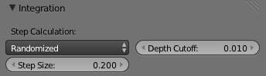
Integration options
Step Calculation Method
Method of calculating the step through the volume.
Randomized
Randomized method of calculating the step.
Constant
Constant method of calculating the step.
Step Size
Distance between subsequent volume depth samples. Step Sizes determine how noisy the volume is. Higher values result in lower render times and higher noise.
Depth Cutoff
Stop ray marching early if transmission drops below this luminance - higher values give speedups in dense volumes at the expense of accuracy.

Options
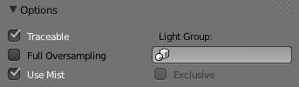
Material volume options
Traceable
Allow this material to calculate raytracing.
Full Oversample
Force this material to render full shading/textures for all anti-aliasing samples.
Use Mist
Use mist with this material (in world settings).
Light Group
Limit lighting of this material to lamps in this group.
Exclusive
Material uses this group exclusively. Lamps are excluded from other scene lighting.

Smoke and Fire

Create the Material
The material must be a volumetric material with a Density of 0, and a high Density Scale.
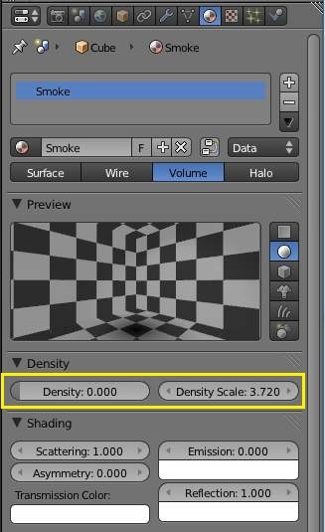
The Material Settings
Smoke requires a complex material to render correctly. Select the big cube and go to the material tab. There change the material to ‘Volume’ and set the density to 0. If you set the density to values bigger than 0 the domain cube will be filled with the volume material. The other settings will affect the smoke, though. We’ll cover those later.

Add the Texture
In addition, Smoke requires its own texture, you can use a volumetric texture known as Voxel Data. You must remember to set the domain object and change the influence.
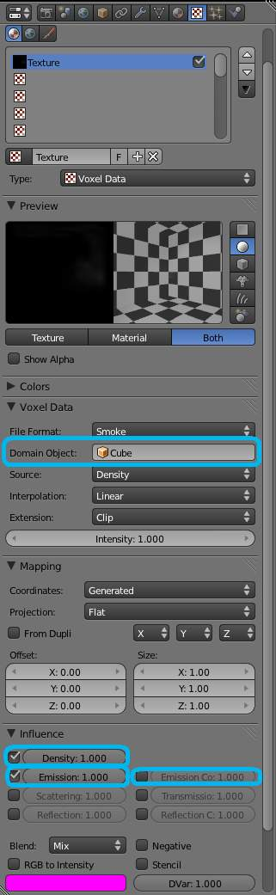
The texture settings.
Go to the texture tab and change the type to Voxel Data. Under the Voxel Data-Settings set the domain object to our domain cube (it should be listed just as ‘Cube’ since we are using Bforartists’s default cube. Under Influence check ‘Density’ and leave it at 1.000 (Emission should be automatically checked, too). Now you should be able to render single frames. You can choose to color your smoke as well, by turning Emission Color back on.
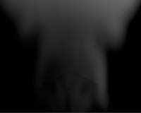
Finished Result
Tip
To see the smoke more clearly
Under the world tab, chose a very dark color for the horizon.

Extending the Smoke Simulator: Fire!
You can also turn your smoke into fire with another texture! To make fire, turn up the Emission Value in the Materials panel.
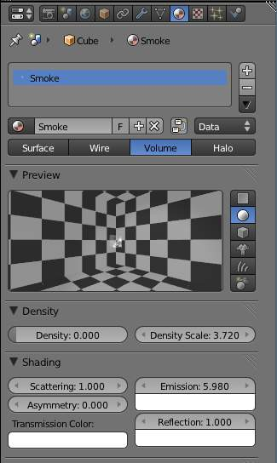
The Fire material.
Then, add another texture (Keep the old texture or the smoke won’t show). Give it a fiery color ramp- which colors based on the alpha, and change the influence to emission and emission color. Change the blend to Multiply.
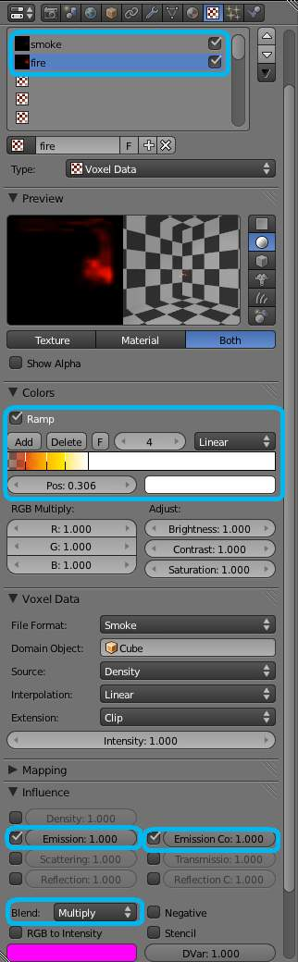
The fire texture settings.
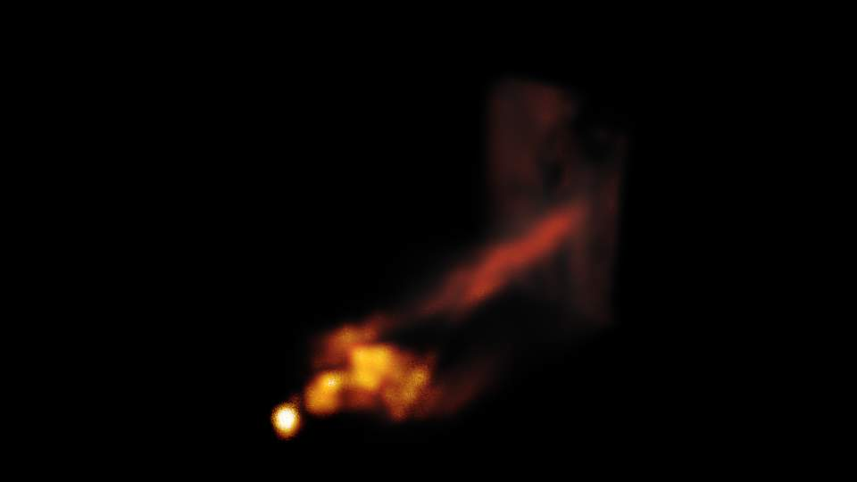
The fire render.

Wire Render

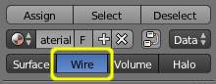
Wire Render
The Wire Render option in the Materials section provides a way of showing a rendered image of the edges in an object. Each edge is rendered as a single-pixel image of the edges which make up the mesh. The colors, alpha and other relevant properties of the lines are selected with the same control panels as provided by the Surface rendered image.
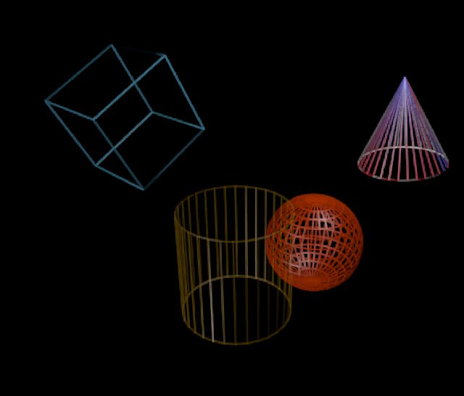
Wire Render

